General Comments
- Are there rules for password creation? (If so, please indicate this, as I tried to create one with letters only and failed, then tried to do so with a combination of letters and numbers – this worked). – Need to mention Password Policy Below password field
- Can we set a standard to register the name? Its either single name or full name? The tool can then display the First name in the header part. – Need to Mention Full Name all fields
- Flags on the currencies. – Country Flags for Currency
- Capitalisation where necessary. – Okay
- At the time of registration, should we include a telephone number? Is it possible to allow mobile verification or send an SMS to just confirm that account has been created? - Need to add Contact Number while Registration and email Verification need to implement for user registration ( Need to mention Check email for Verification Code “ )
- Once a user has signed in, increase on spacing between the test “Hi David Test” and the text “wishlist”. Alternatively put this at the top where My Profile is. Since this is not a hyperlink. ( Need to removed User name from Down and need to update on Top – Also in dropdown need to add FAQ, Contact us, Help
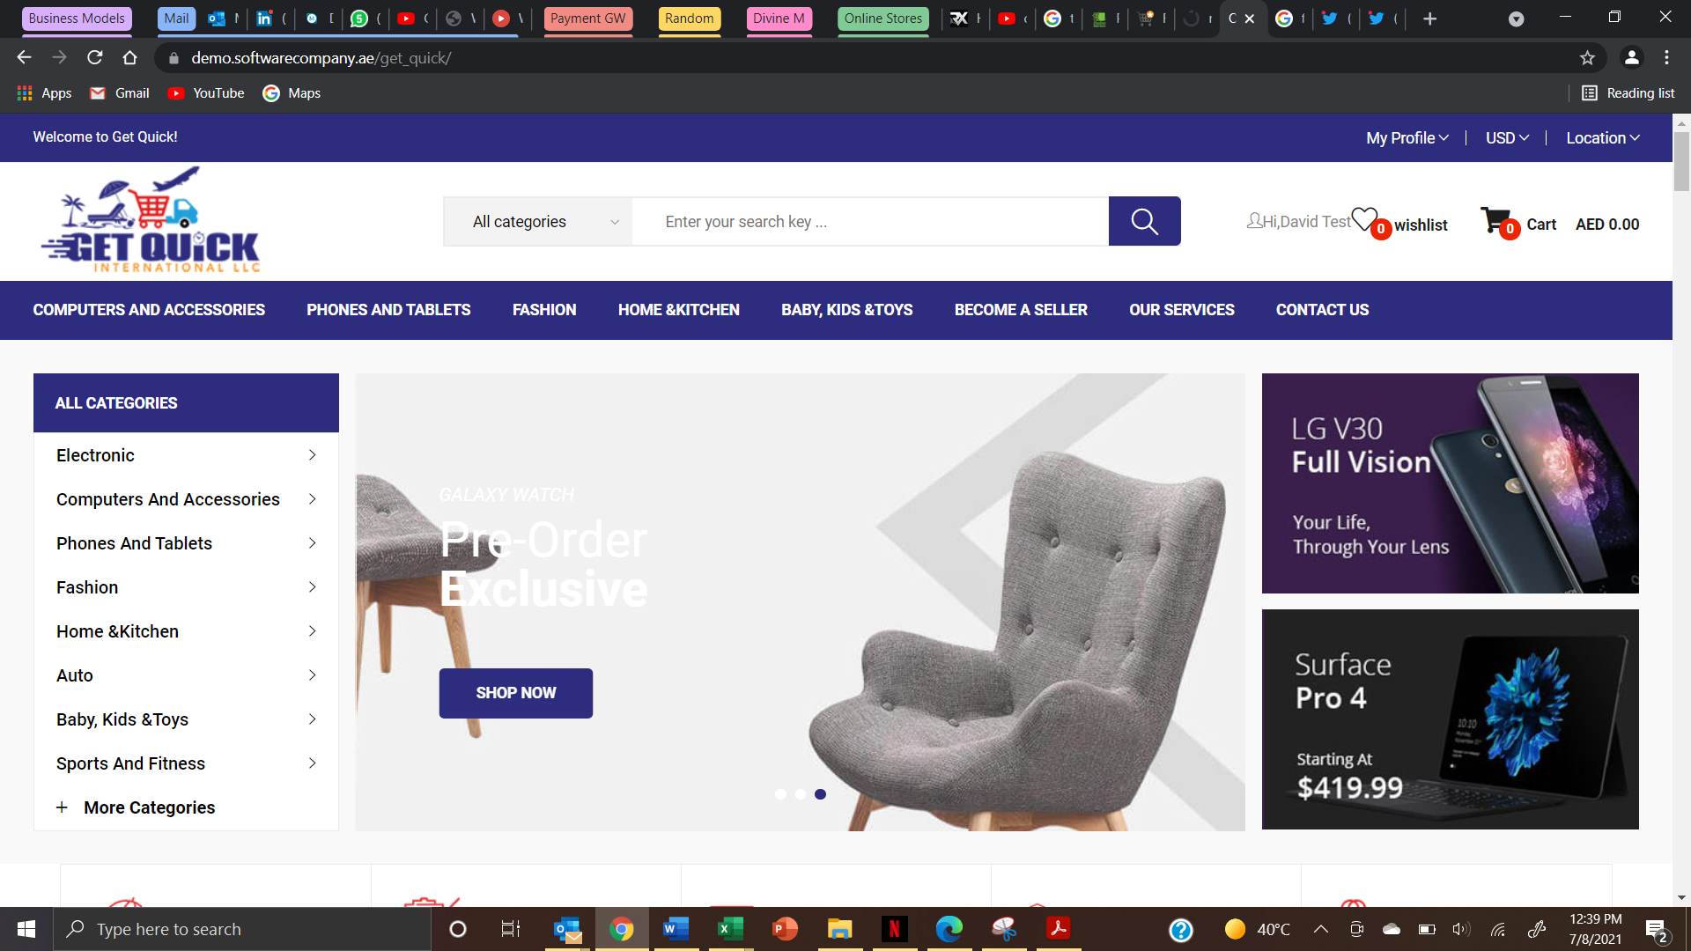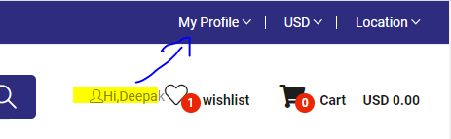
- Change the Logo to new one. – New logo need to update – without LLC
- Payment options in my profile – Need to confirm with PG team to save user card details
- An email confirmation has been received. Can we show sender from a predefined email address? This is currently showing from CarZoom (info@carzoom.ae) - Yes we can – Please share the email and Password
- Customer need to update there name from Profile – Now its not working need to fix it
- On my account page, should not be able to change name. Can we limit the number of times it – Okay We will do it
- Successful update to mobile number – Okay
- Borders of the table on my orders page needs to be fixed – Okay
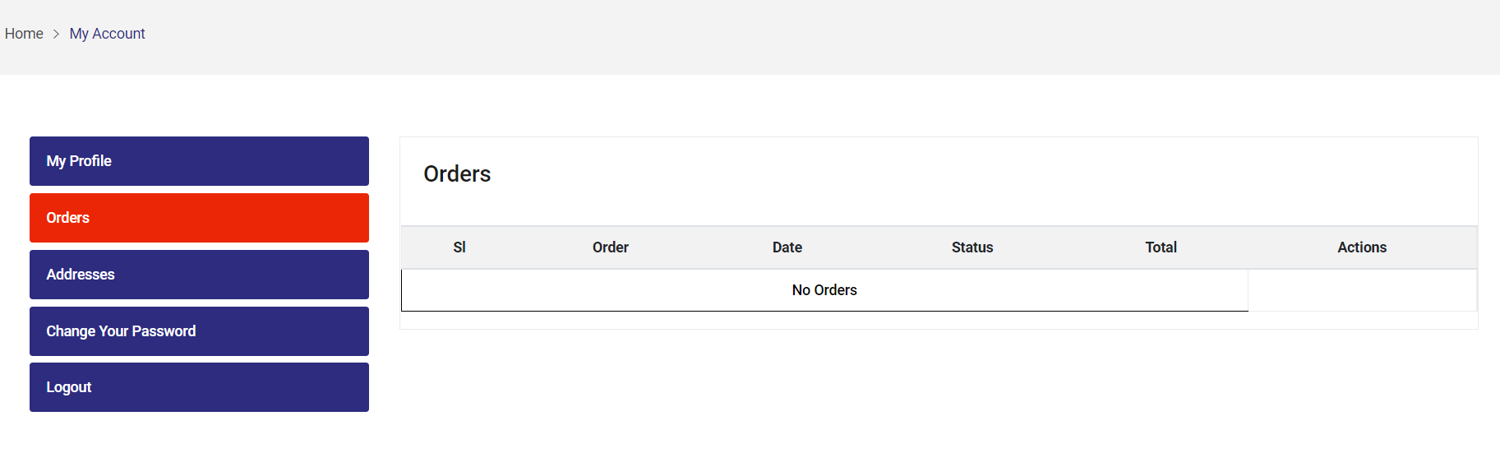
- Can I update my shipping address from here? - Need to add Multiple Address and need to option to select while checkout ( Home , Work , Other When we chose other need option to update the name like Deepak’s Home etc..)
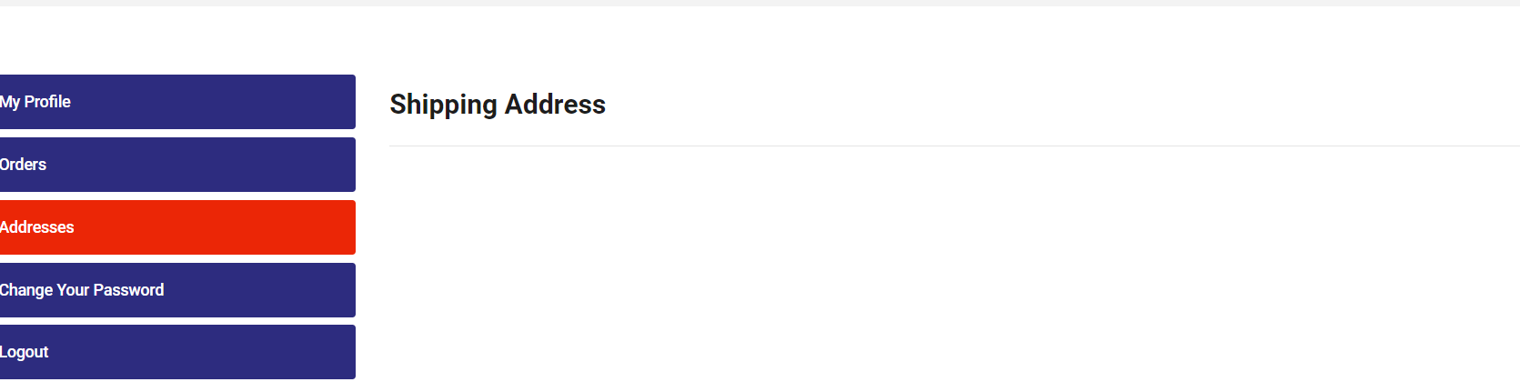

- Change Ush to UGX on the currency tab – Okay
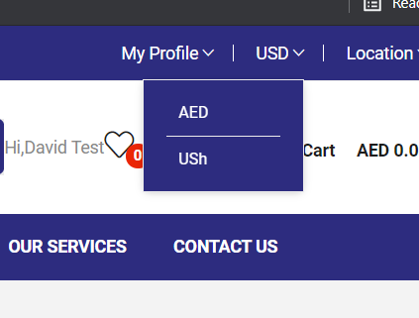
- Electronics rather than Electronic under the categories. (This is applicable in all menus). Drop down not working at the moment (28/07/21) - Need to fix the search and dropdown
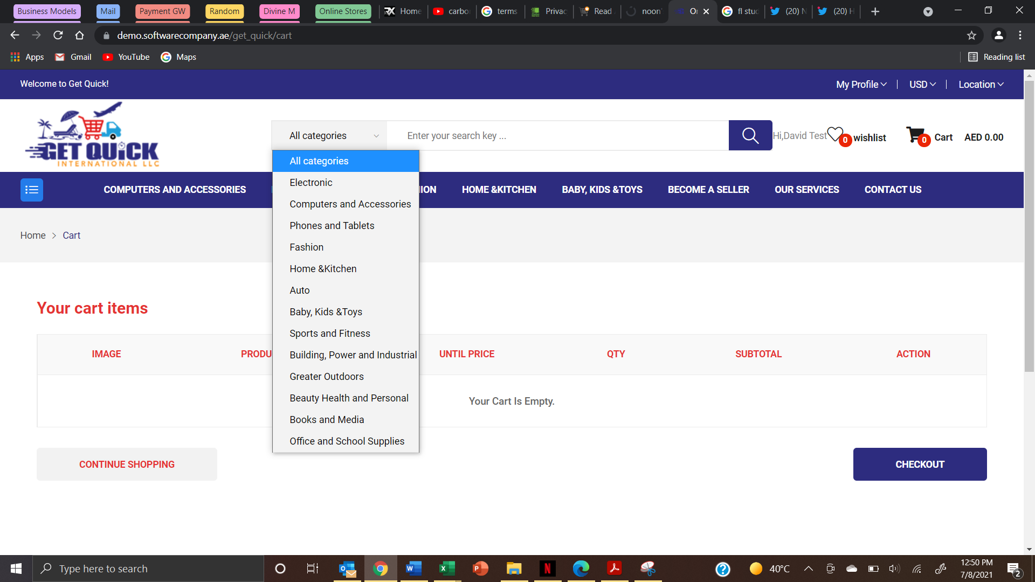
- Spacing keeps changing between search bar and name. – It will fix while we change the User name position to top
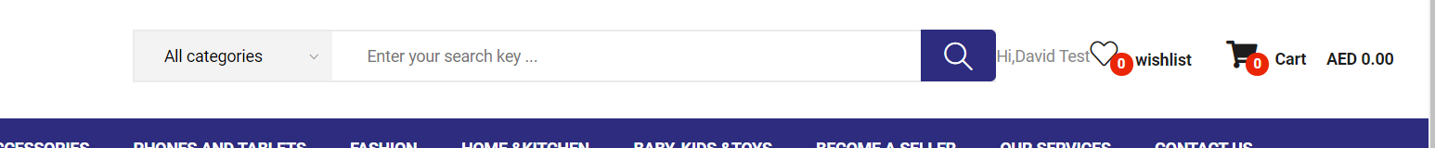

- Need to fix the categorization more. For example, as below: Need to update from the given category & Subcategory List
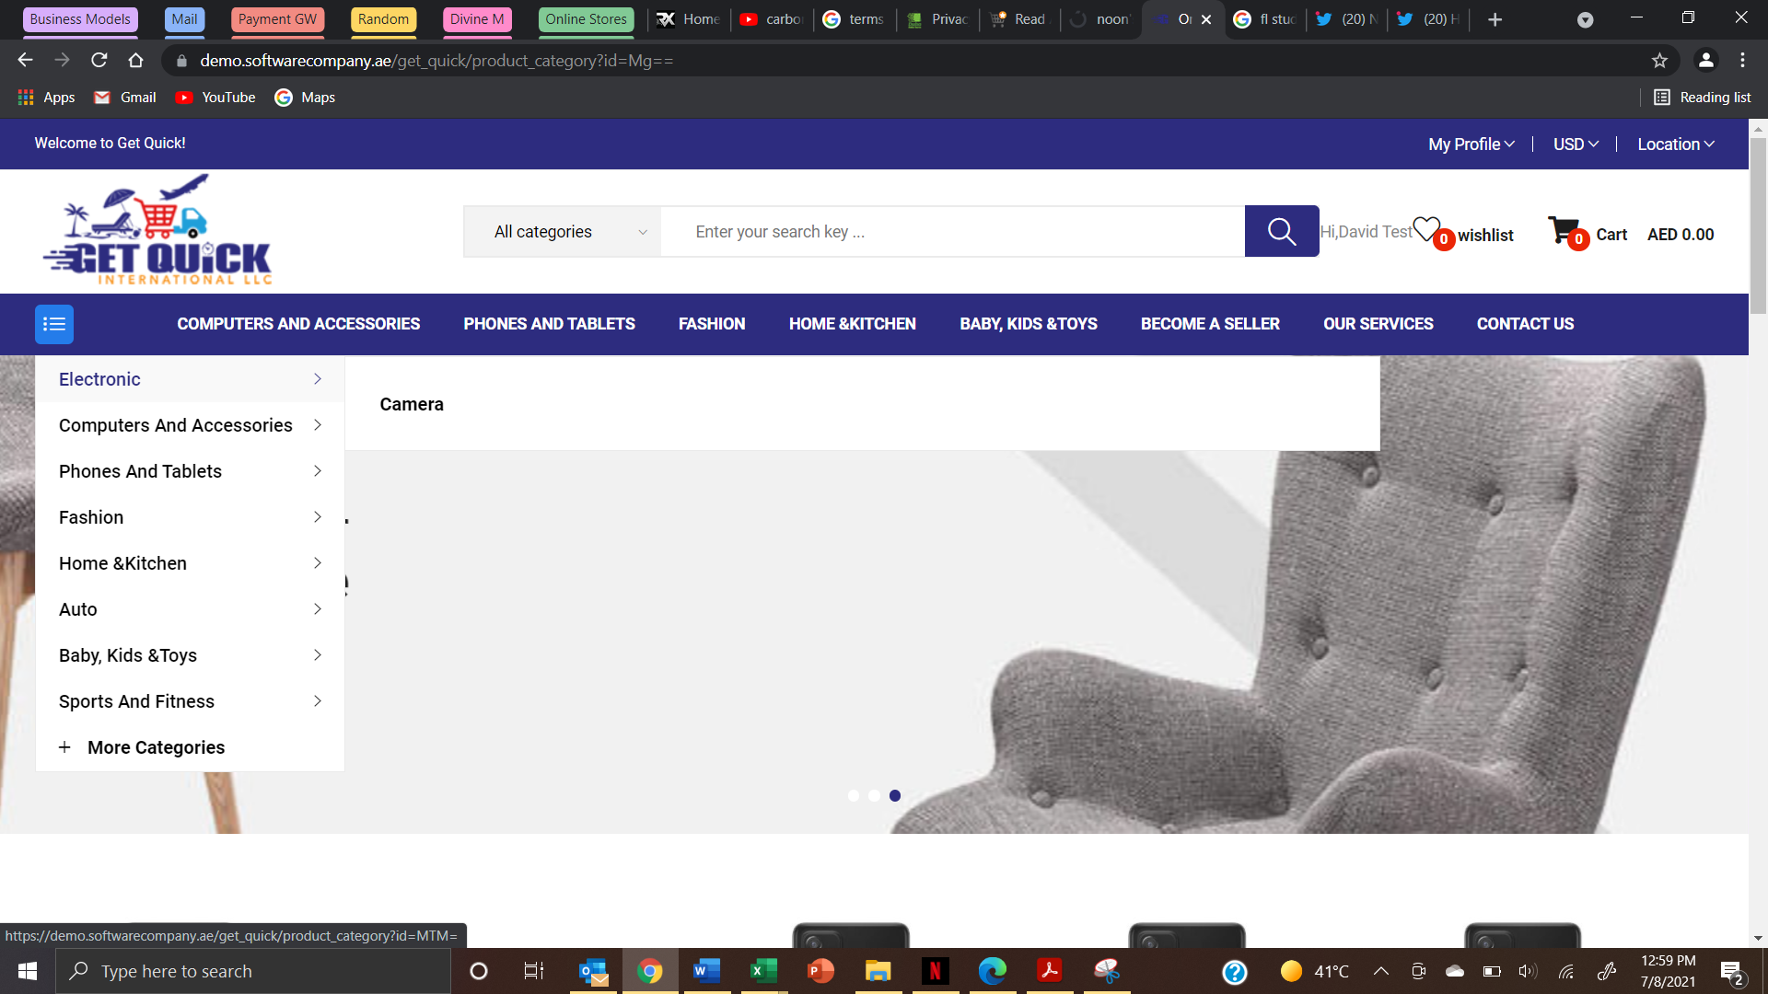

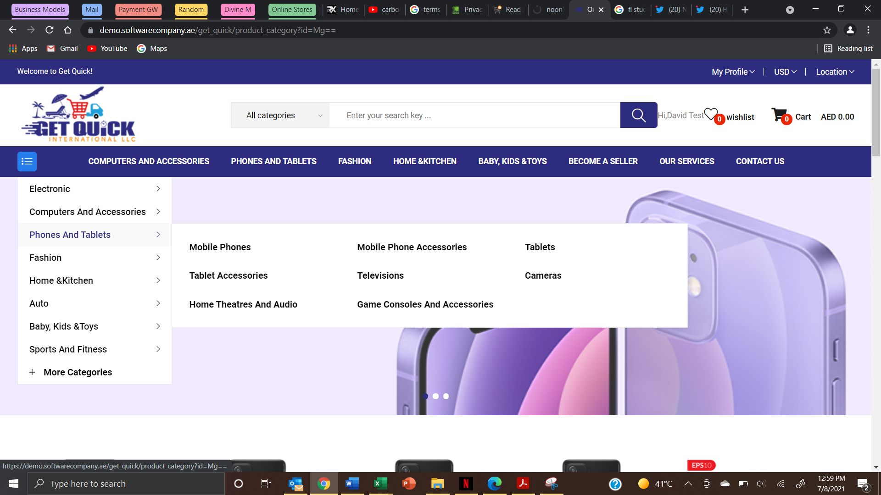

- Consistency on the menu. If using ‘AND’ or ‘&’. Also spacing after ‘&’. As below - Need to Stick On & Home & Kitchen ( Spacing need to take care )

- Include “More Categories” on the top menu as a drop down. It looks like those 4 are the only categories available – No Need to work on this point
- Are the sub categories configurable as this is only applicable in the computing and accessories “Main Category”. As below
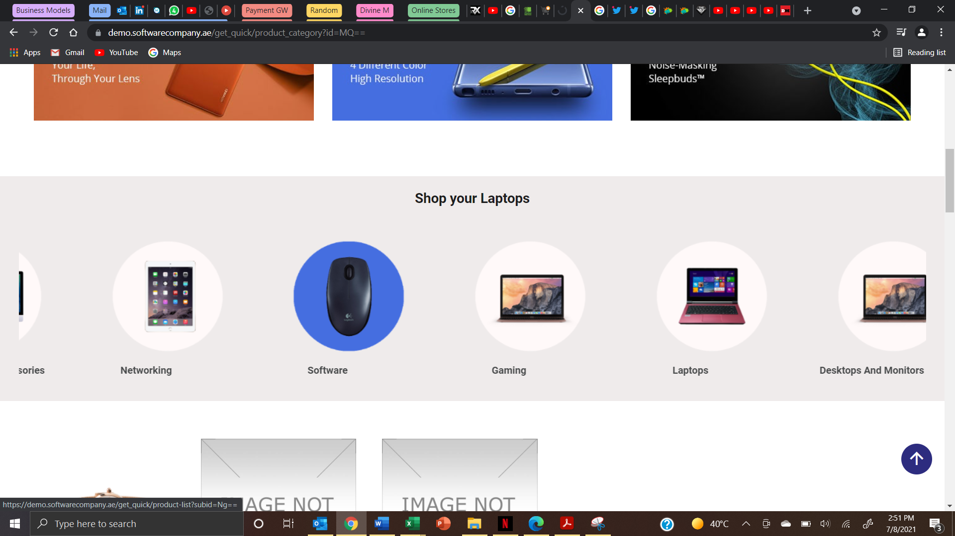
- There is no heading for this category. Are headings configurable? (This seems to be fixed when tested 28/07/21) - This is fine now
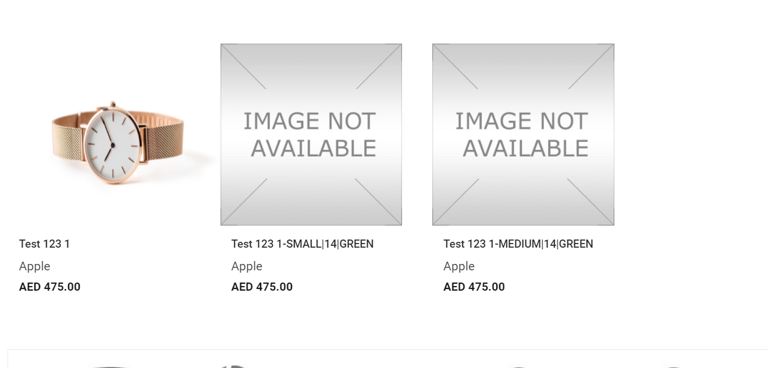

- Navigation. Show the current page. This is on holiday packages under the services. Make it easy for one to navigate back. Either make it a hyperlink or introduce a back link - This is need to update Services page


- Can each of the services pages be customizable accordingly. For example, while in holiday packages, request for the following information Name, Intended Dates (from & to), number of people, email, Querry. Car rental include, Name, intended dates (from & to), type of car, and so forth – Need to update the Enquiry Form based on service
- While shopping, on the point of navigation show the current page. At the moment it shows Shop, making it hard for one to know location - This is working fine now

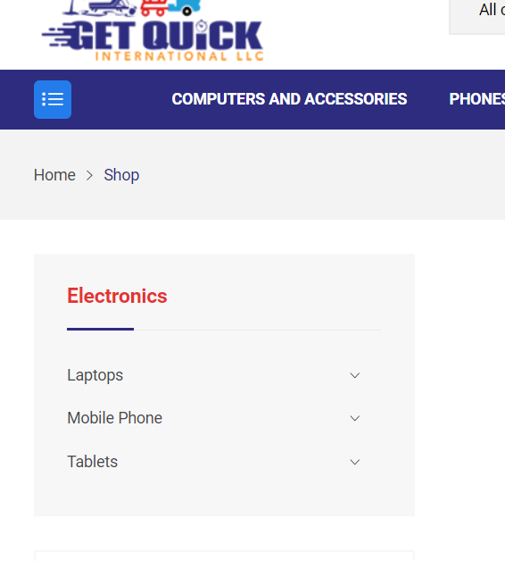

- Capitalization of sentences where necessary – Need to check this for all page
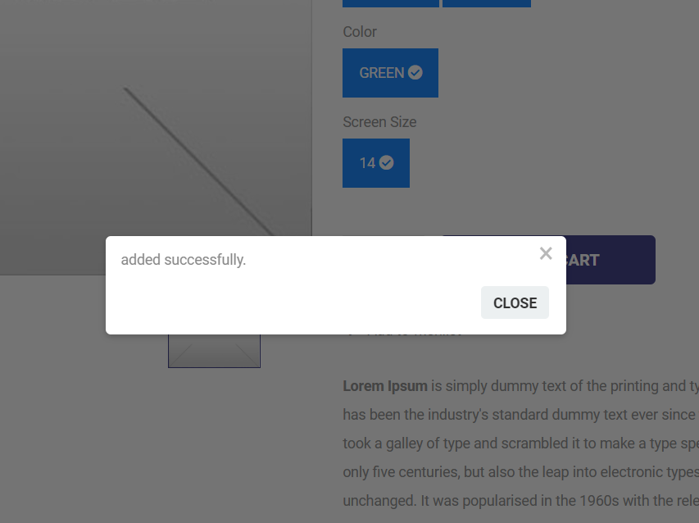

- The “My wishlist” shows header as “Cart items” as below - Need to update whish List Heading
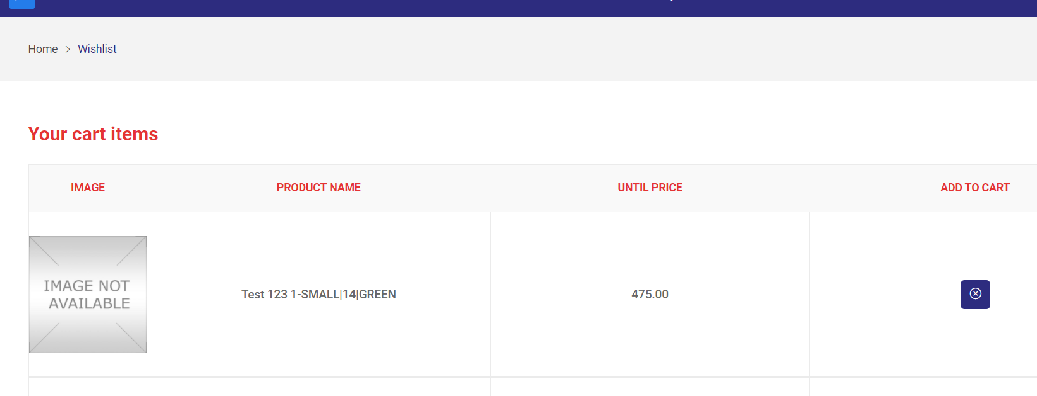

- From the “My wishlist”, I tried to go to a specific item and received a 404 page - Need to check this scenario – In wish list need to click on the product image
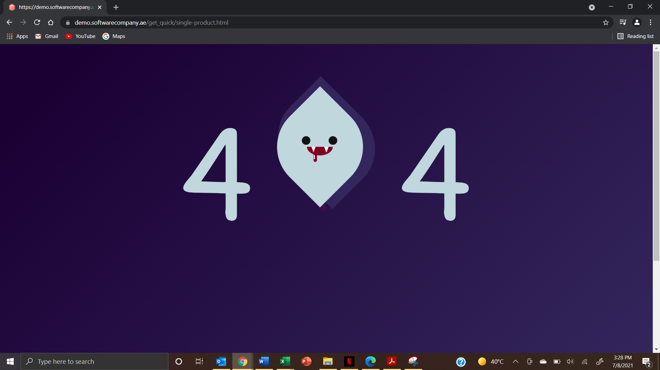

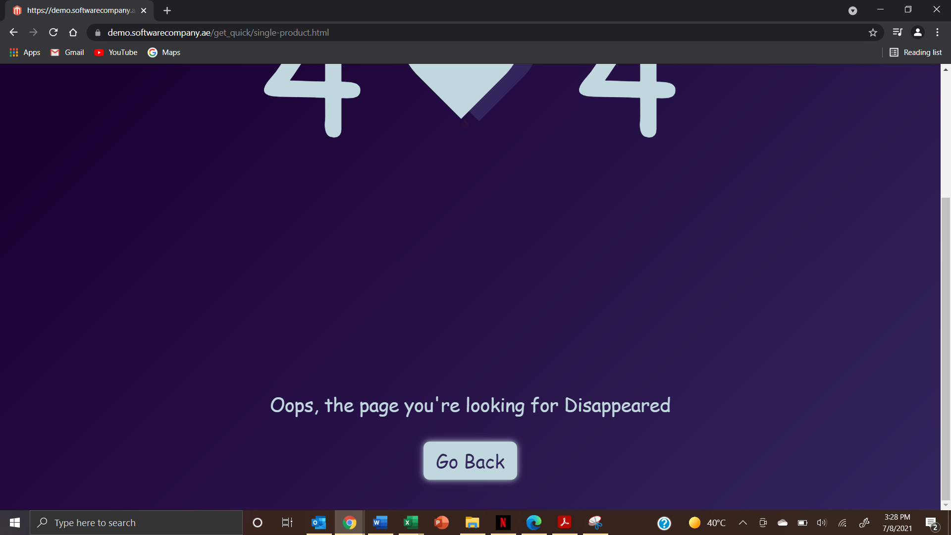

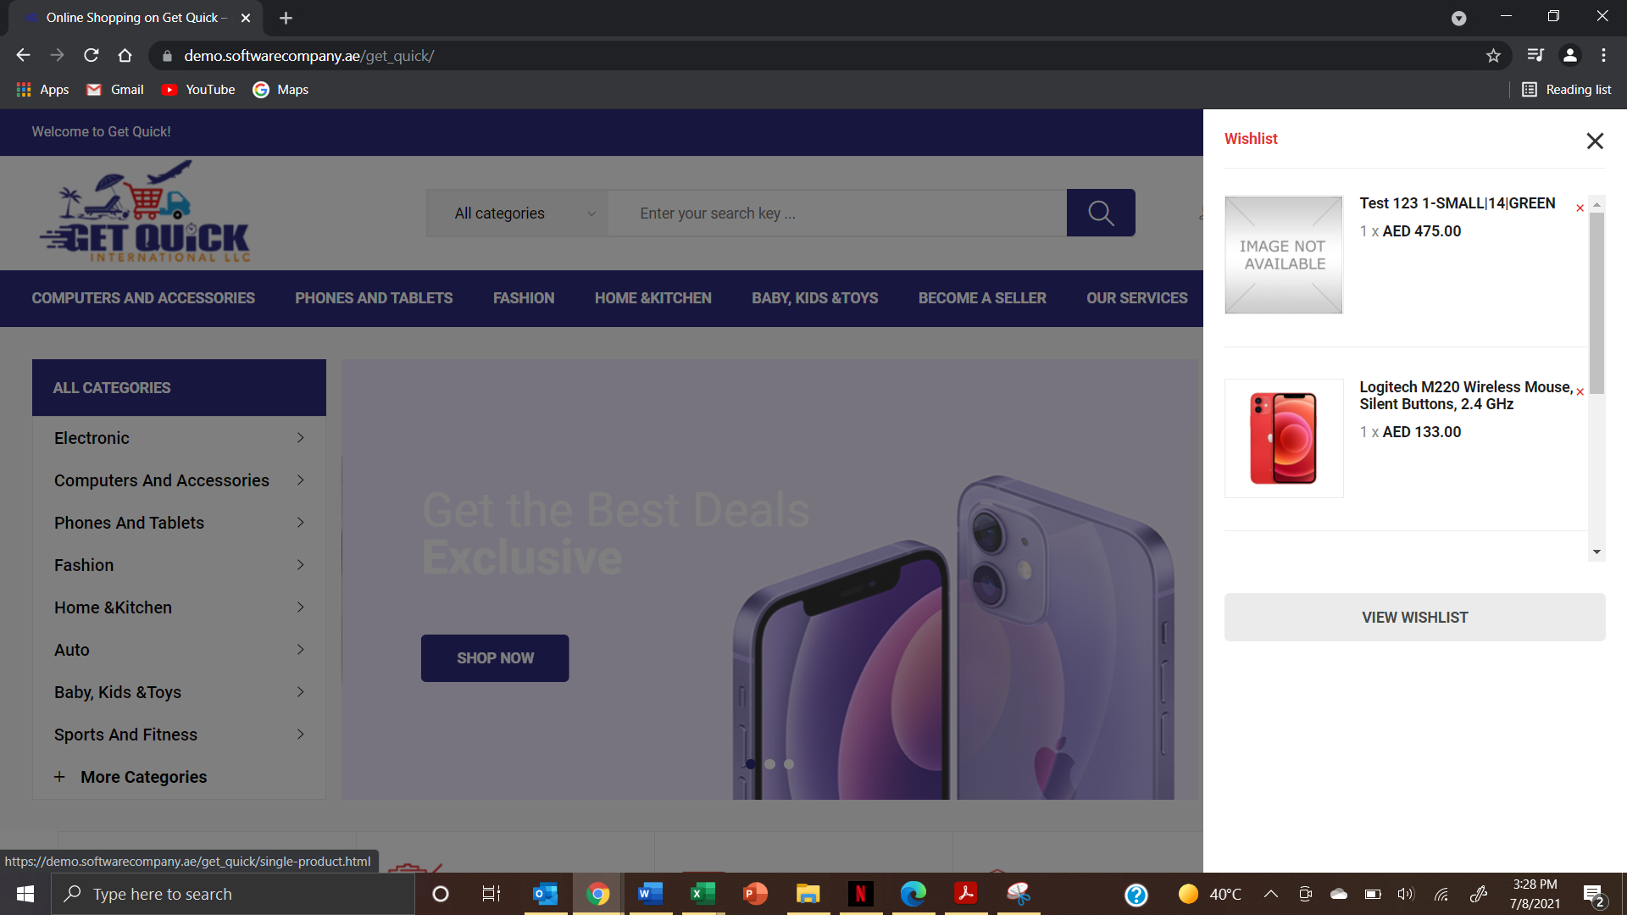

- Initially shows 0 on my wishlist and then it shows new figure – Need to check this – It is showing 0 for milliseconds only and its updating to actual count this is for cart and Total Price also in header
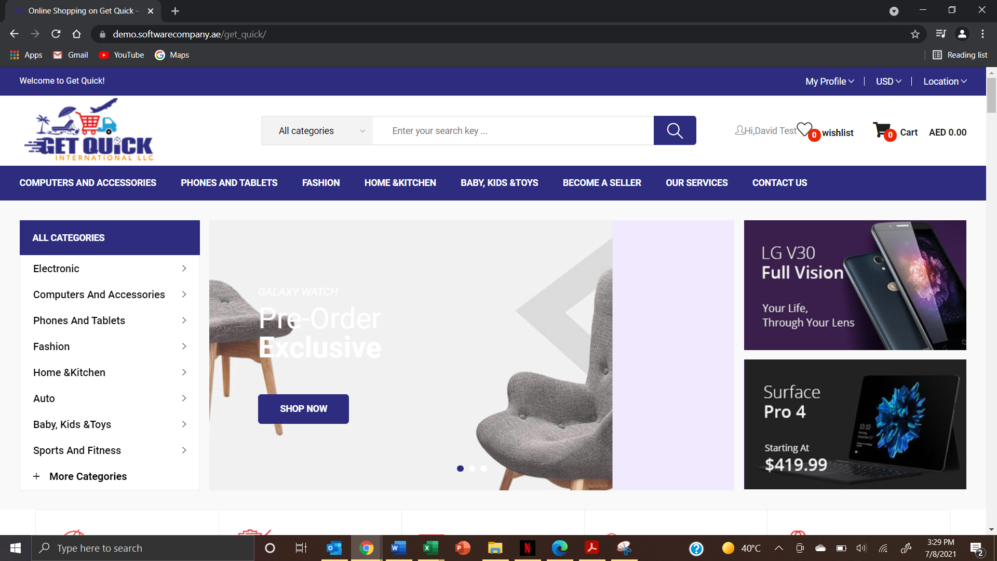

- How to add an item to cart from wishlist. A quick add button perhaps. – Need to have an add to cart button near to delete option
- Item already on wishlist should not show add to wishlist again –No need to work on this point

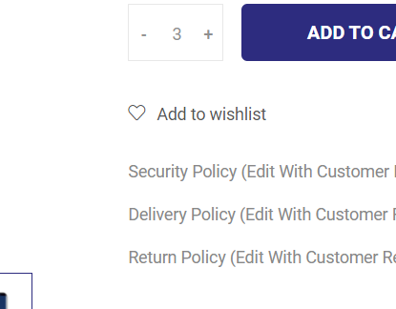
- This needs a rework in terms of rephrasing. Its alittle confusing to the customer about the charges.
Sub Total
Shipping charge ( Sum of Air category + Flat Fee+ Shipping Fee) – Need to give one hyperlink to view details )
Grand Total
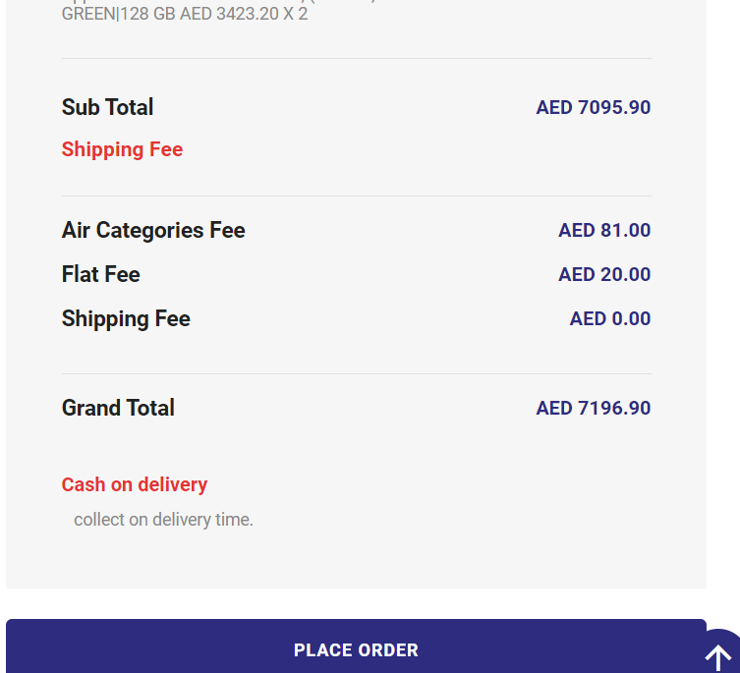
- Allow one to pin address on map as alternative to typing it out. Like on Dubizzle – Ignore this point
- It is not picking my telephone number that I updated in my profile. But its ok, it allows one to fill it out. Maybe an option to say use existing or new number. Sometimes one does not have a number on their profile, while another might have.- So each Address will be having different Contact Number and we will select Home , work etc while checkout
- Allow one to choose payment method i.e. Cash on Delivery or Pay online (this will take one to a payment page that will be determined by payment GW)
https://demo.softwarecompany.ae/get_quick/checkout
Need to Replace
- Billing details page – Need to arrange the form fields Position
- Not mandatory to include state name, as it prohibits one to submit the form. Rather keep it at Country-City – Area ( Area Text Box) In shipping address. This is the same as the postcode and other fields – Keep all fields are mandatory
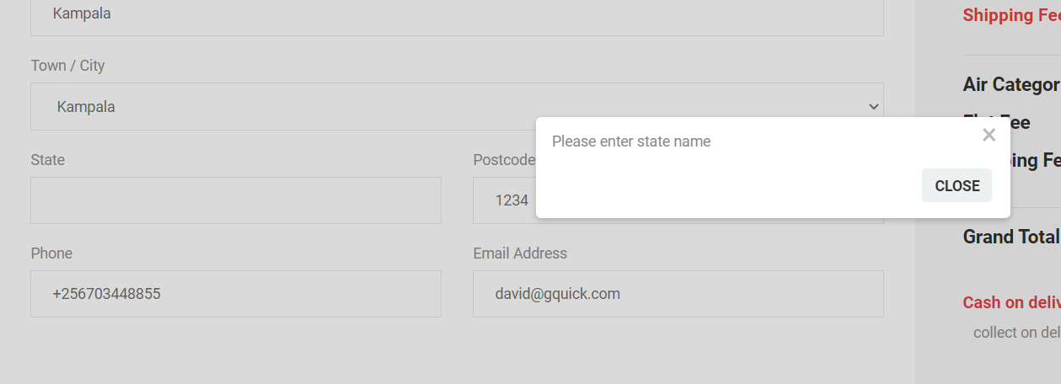

- Receiving a Wishlist error – Please double check
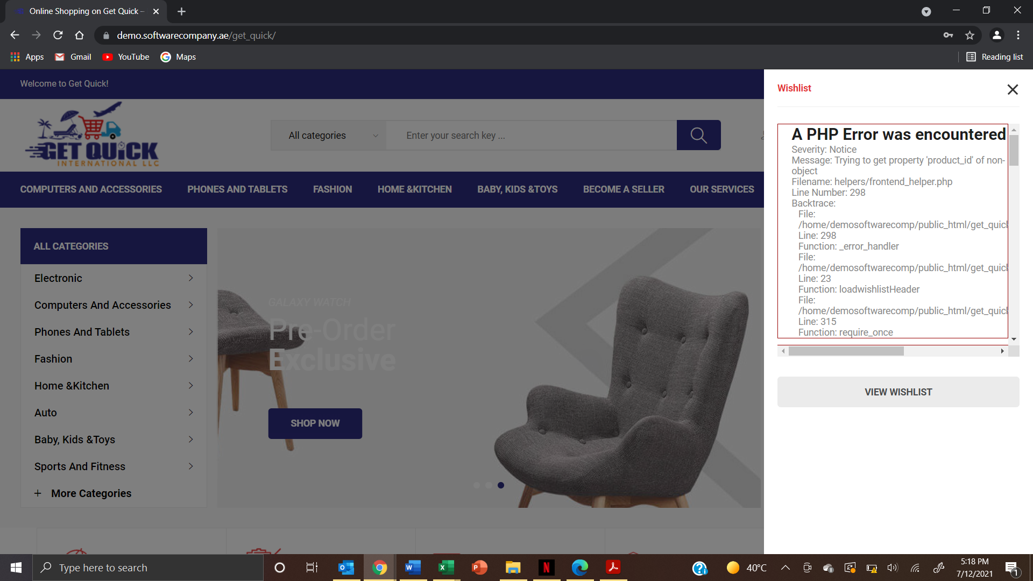

- Would like to see how to generate and apply a promo code. – This we will discus on admin Session
- Status in personal order page, need some clarity on the statuses i.e. received. (what does that mean?) -
Vendor status as follows – Order Received – Order Accepted – Order Cancelled
Customer Status as follows – Order Placed – Order is in Progress ( Automatic ) Order Confirmed ( if all vendor accepted automatically change to Order confirmed – Getquick admin also can update the status as order confirmed – Order Shipped – Order Delivered
- Need more clarity on the details being shown on the order page for individual purchase – Discussed above – Mention as Delivery charge only with hyperlink
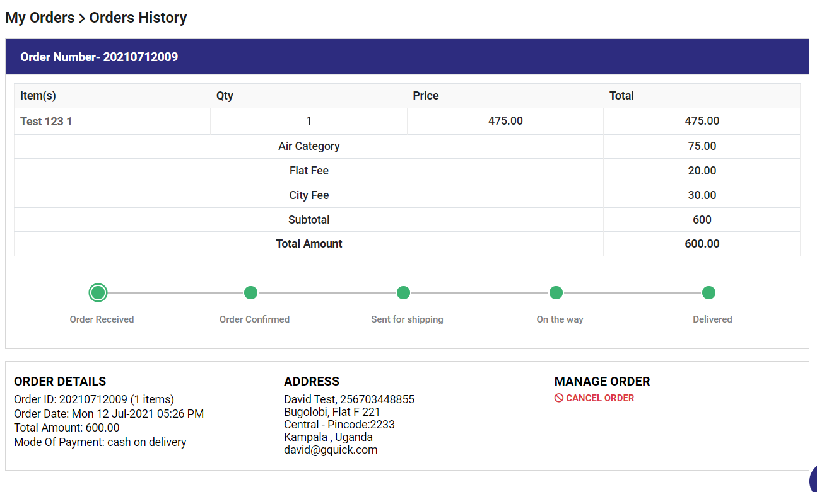
- For Orders greater than 15Kg
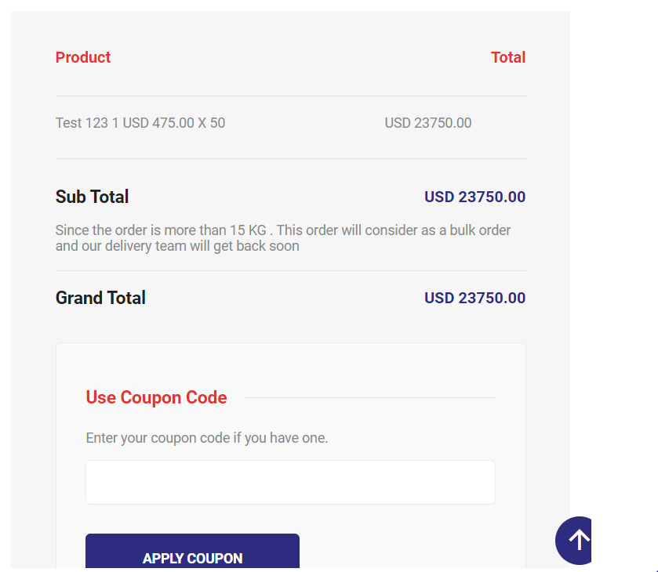
- Should the bulk orders be shown as confirmed immediately and yet we mention that the delivery team will respond? – Fine
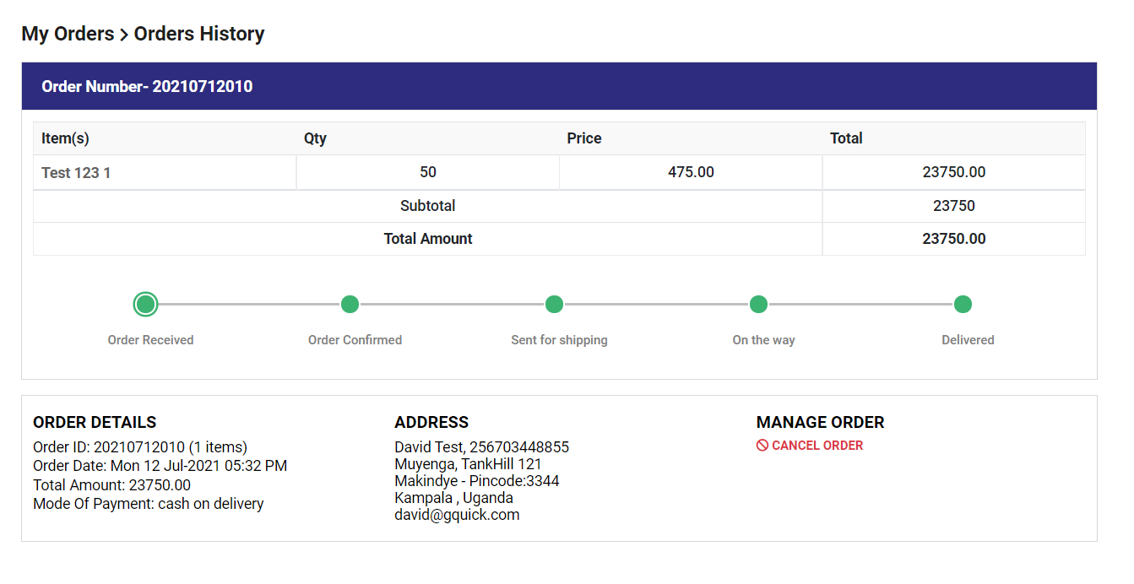
- A link to the copy of cancelation and refunds policy should be included when one chooses to cancel order. Okay
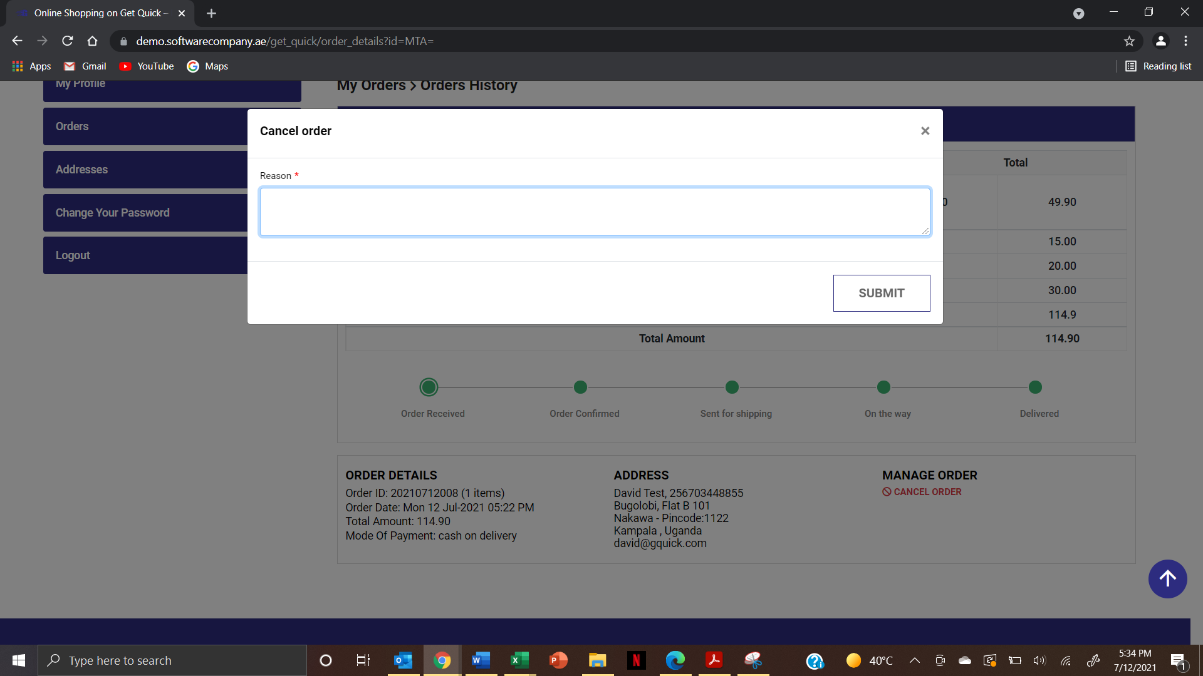
- A breakdown of what is refunded or not, should be highlighted in the cancelled order page – This will be in; cancelation and refunds policy
- Need to add two option while adding product – No Refund No Cancellation ( Check Box ) – If its enabled Then only it will appear in Product details page and Cart page

- In cart Page – Need to have 2 options – Delivery Or Pick Up Location
If its delivery work as same flow – If its pick up – Choose country then locations need to appear with radio Button – If I chose Pick up then no need to add City delivery charge

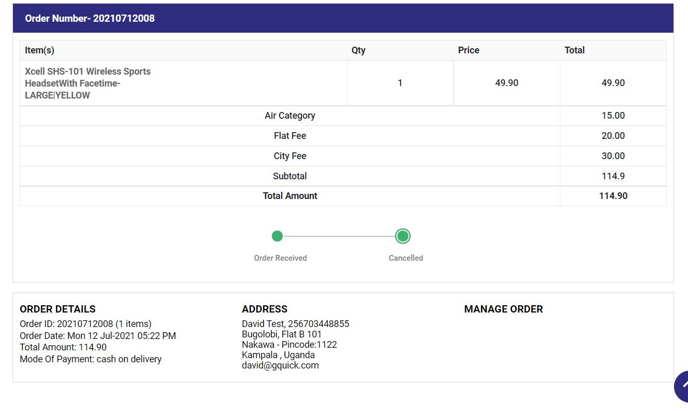
- Summary of updated orders. The table borders need to be fixed. – Okay
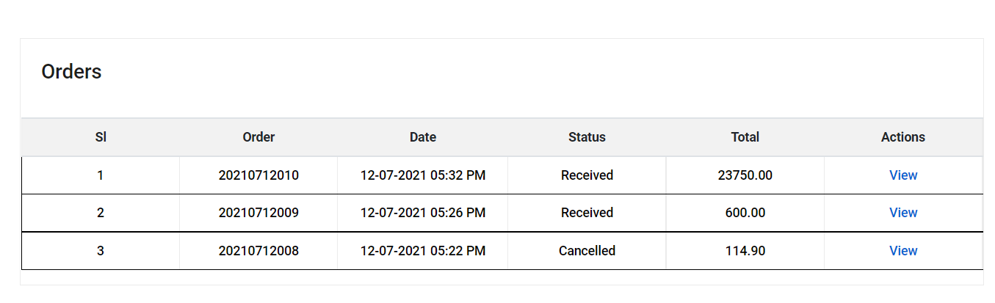
- Allow user to choose from existing addresses or create new address when shopping. I notice that all previously entered addresses are listed. And one can give them different names, such as home, office, hotel etc. – Discussed
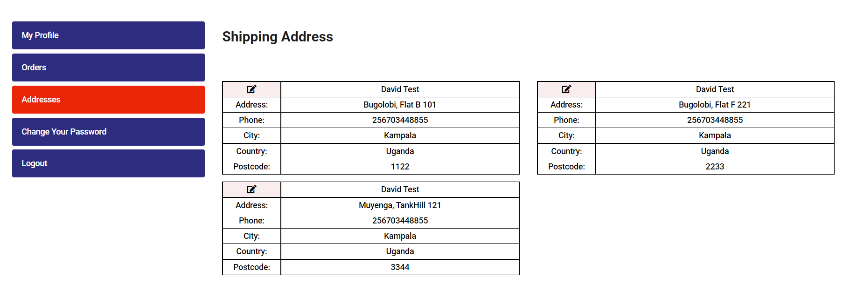
- Allowed to edit and save address. That is great. – Okay

Seller Profile
- When creating a new profile, specify the proper requirements one needs before proceeding. Better than trying to create a profile and then get stuck because of lack of certain details. Same goes for image upload. Need to collect Trade License and ID Upload option
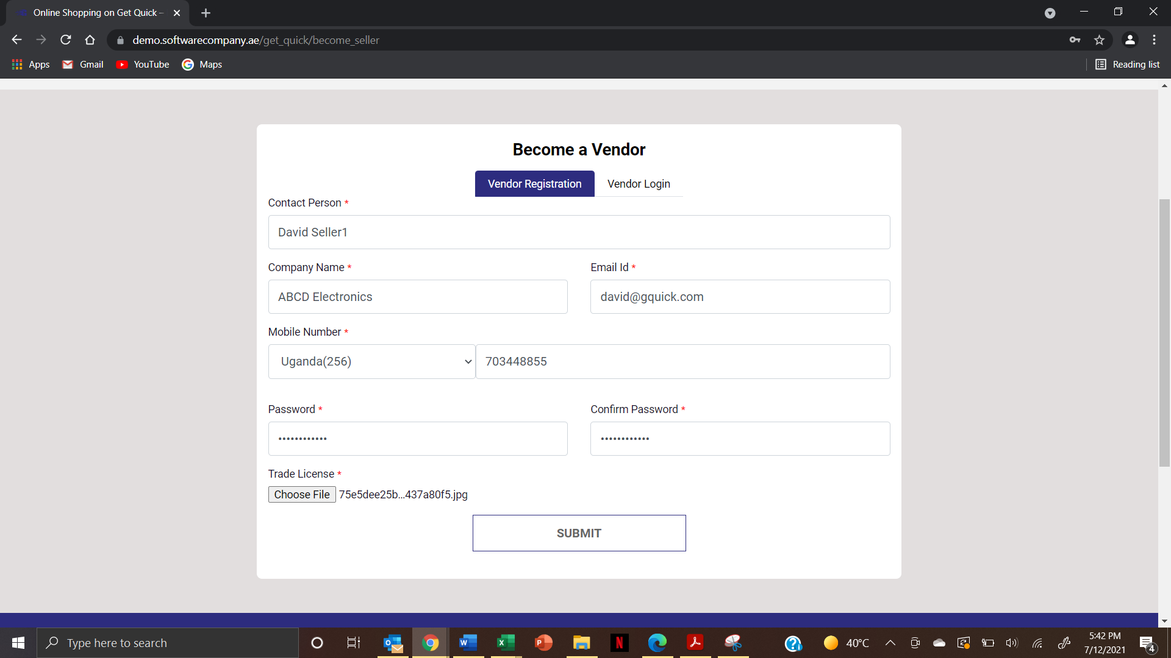

- 2 instances for login/sign up in the top right hand corner. An this be limited to one only. Preferably the one in the blue banner area - Keep Only One
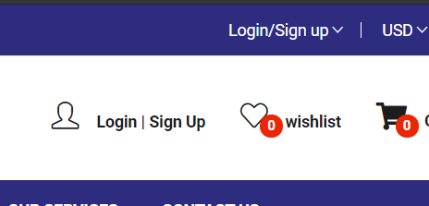

- Unable to proceed as vendor until approval is confirmed. – This is Fine
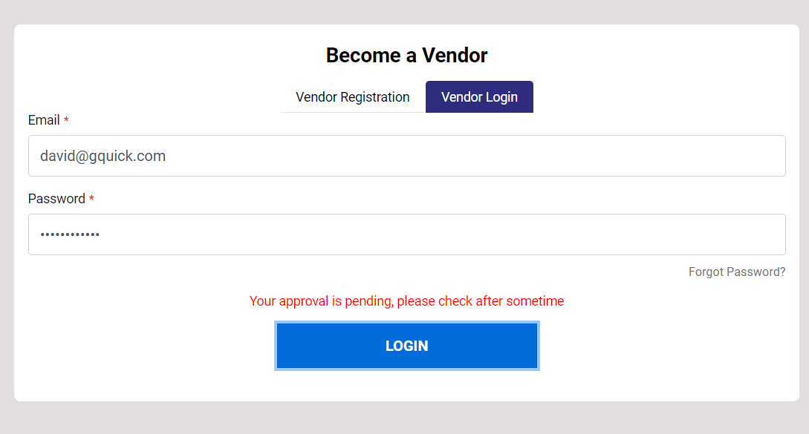

- If I use the same email ID as a buyer and seller, which profile takes precedence? No Priority – One Id can have Seller and Buyer account it will work based on the login
- Current amount in the cart? – This is discussed Above Value 0 coming while refresh
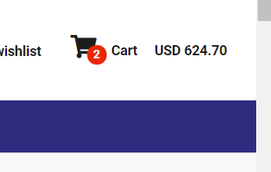
- Need to sort out the notifications as follows: - We will double check these mails
  - Account creation
  - New order made
  - Change in order status i.e. delivered, cancelled
- Notification received confirming that account has been approved – This is fine
- What is SKU Code (when entering product details). Its not mandatory but it doesn’t allow you to submit form. See below. Maybe we call it something that the seller can easily understand, as well as buyer – Ignore

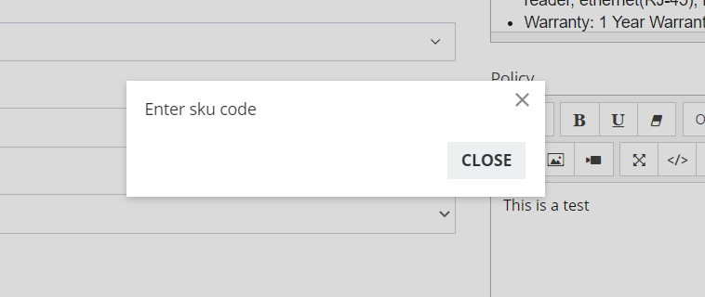

- Discount in percentage should not be mandatory. I applied a 0% on item. – Okay it should accept even % is blank
- Where do I enter product information e.g. processor brand, RAM size, Memory etc – this is just specific for computers. All details pertaining to item. - Need to add Specification for Each product – This is from admin and vendor can add if they have any specification – if not it will not appear in product detail page
- Negative price, percentage, quantity, weight etc (all numbers). That means integers field was selected -Validation
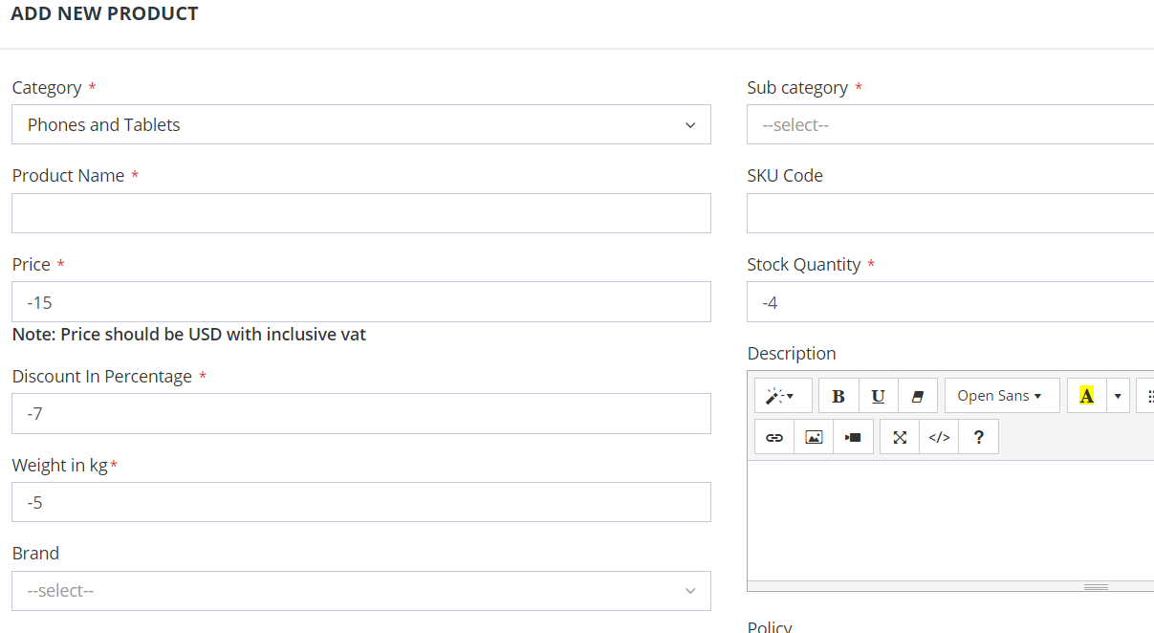
- Maintain font size and type through out - Need to check this
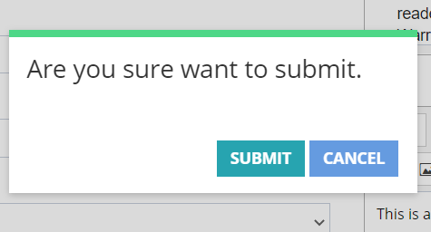
- Need more training on adding variations and attributes – Okay we will have this on admin and seller panel training
- This is a new screen. Is this how vendors will access it? - From Here also seller can login 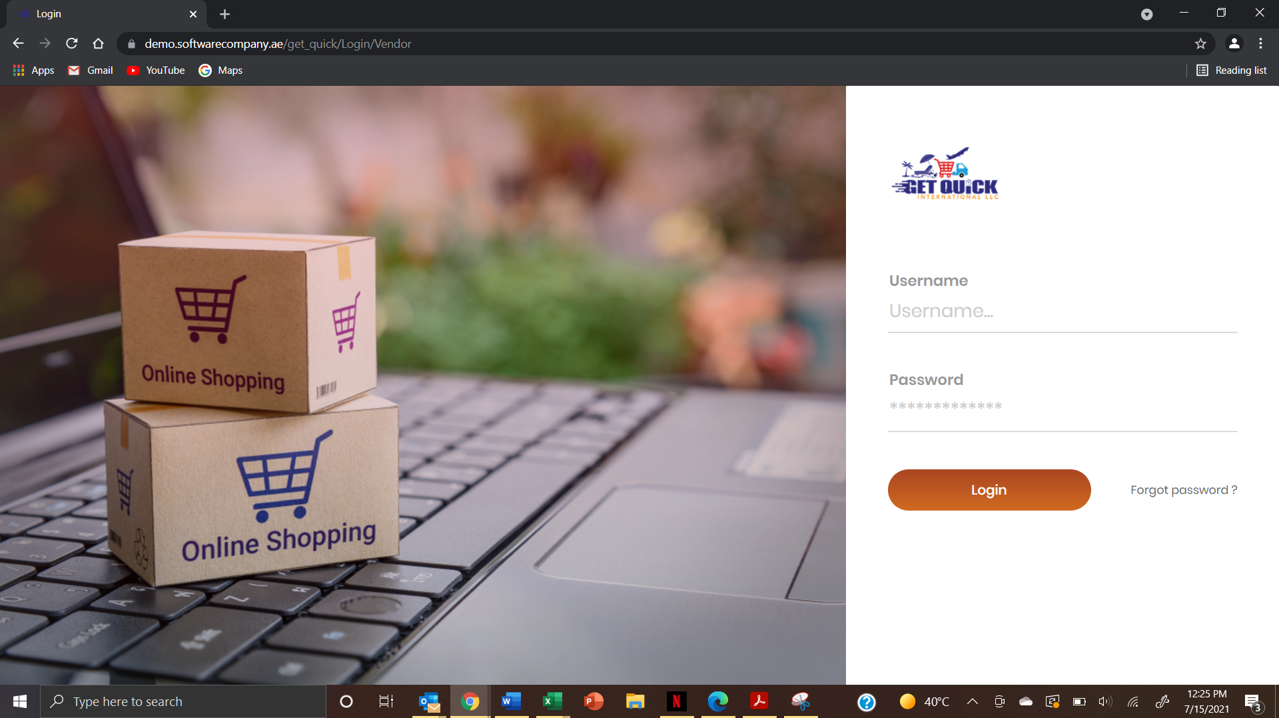
- Use of enter keyboard button to login not functional.- Need to fix this
- New item created has 2 reviews already and yet nothing has been entered. Review need to check
- Need to also ensure that right information is displayed. (Air category)? – Air category Need to hide
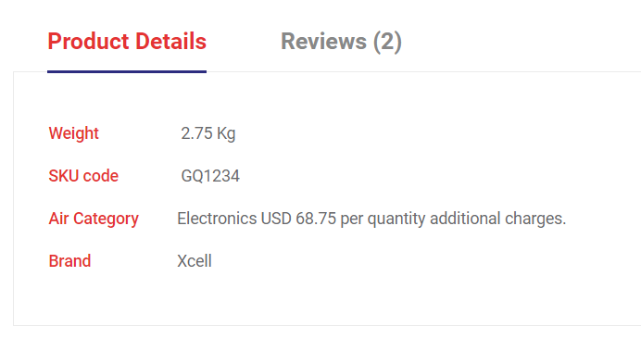
- Entered details using bullet points in seller, however not showing on item under buyer profile - Need to check text editor functionality
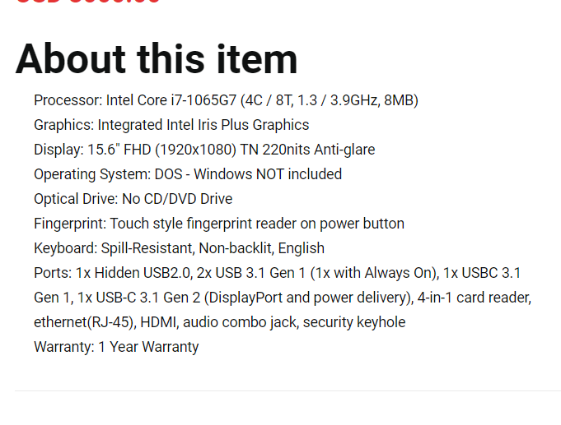
- Currently in Computers and Accessories> Laptops however as per navigation this shows something different – This is fine

- When I select a category from the menu bar, can the current selection be highlighted (whatever category I am in. Either darken the font color, or border it) - This is discussed on above
- Consistency in the wording. Vendor and Seller – Keep as Seller Everywhere
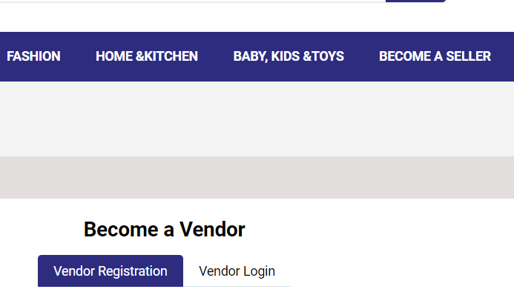
- How to add brands? – In training
- Ability to reorder images while uploading in Product settings. This is working for first in mode. – Its working fine -ignore
- Add and delete attributes – In training
- Add and delete products (I am nolonger selling it – inactive?) – Inactive
- Click on status to change Inactive to active and vice versa – Okay need to fix
- Some items don’t have weights, while others do. – This is attributes again. – This is related to product specification
- Variation in attributes e.g. country of origin, manufacturer, dimensions, Date available, scent etc - This is related to product specification
- Delivery matrix. When will it be available for delivery – Ignore this point
- As a seller, where do I manage my account? Change password, address, telephone contact etc - We will check this and update you in training
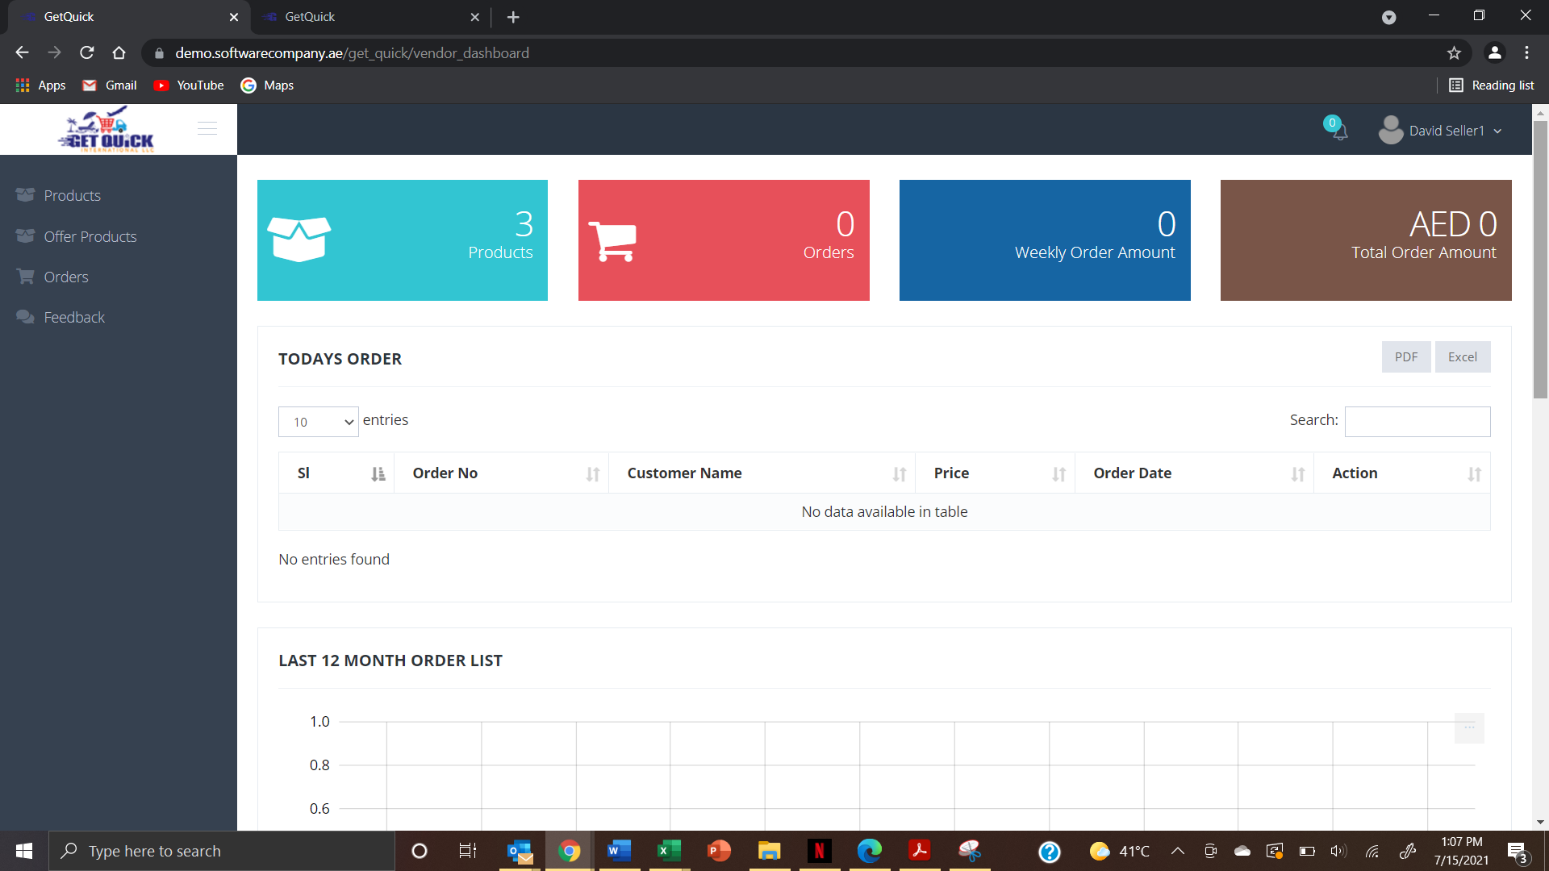
- Menu fixing, something like below – Alignment and highlighting the menu and sub category need to fix

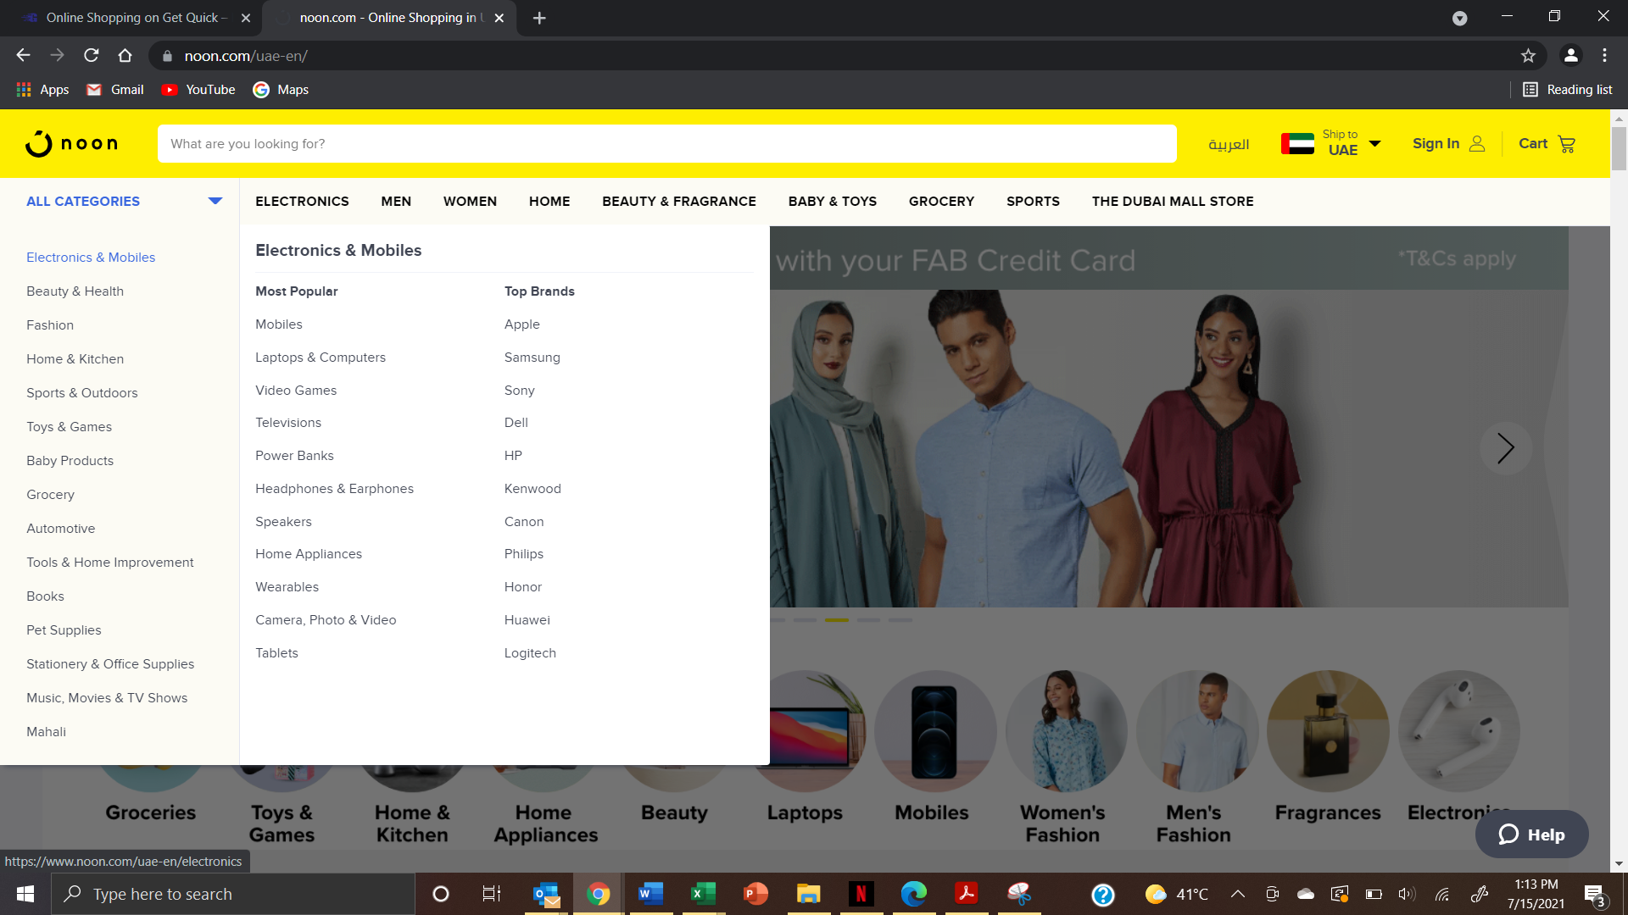

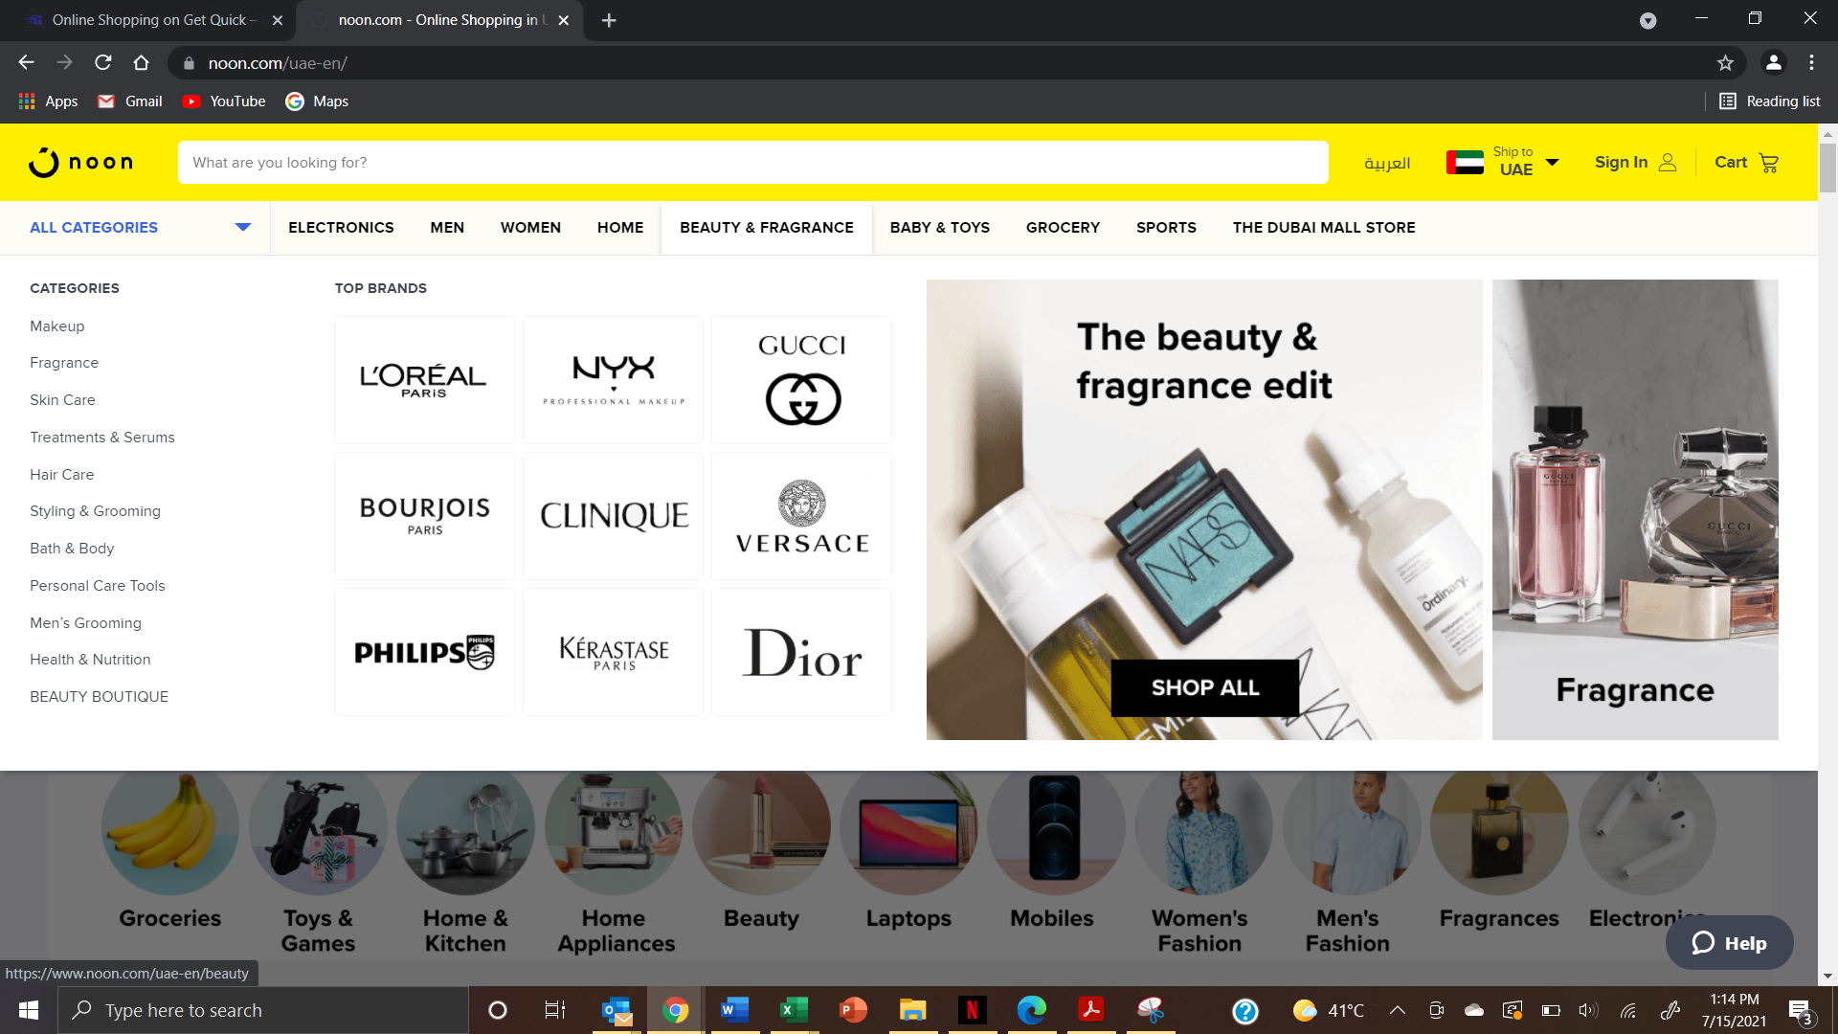

- Spacing needs to be worked on. Visually not appealing - – Alignment and highlighting the menu and sub category need to fix

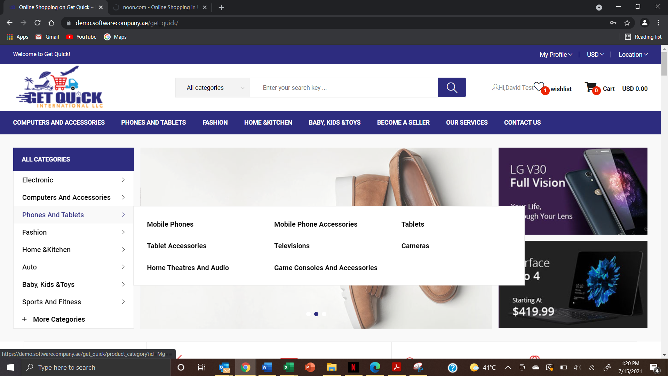

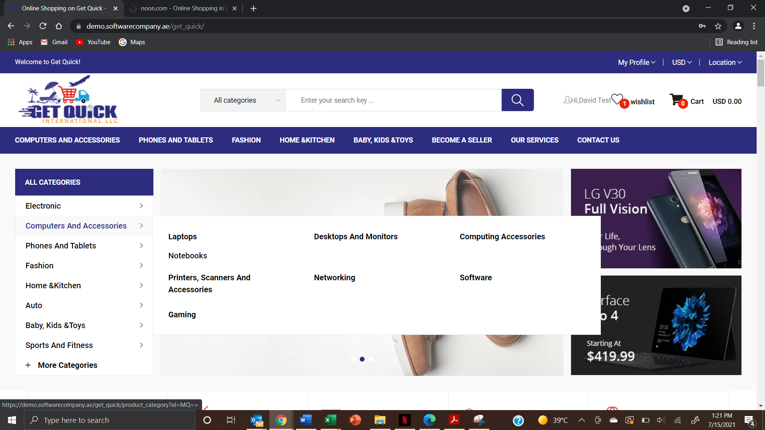
- Created an item in offer products and it did not reflect on the page. Instead it went to the main products listing – Need to check the flow
- How to remove an image that has wrong specifications. Also reordering the images attached to an item – Now working fine – Please double check
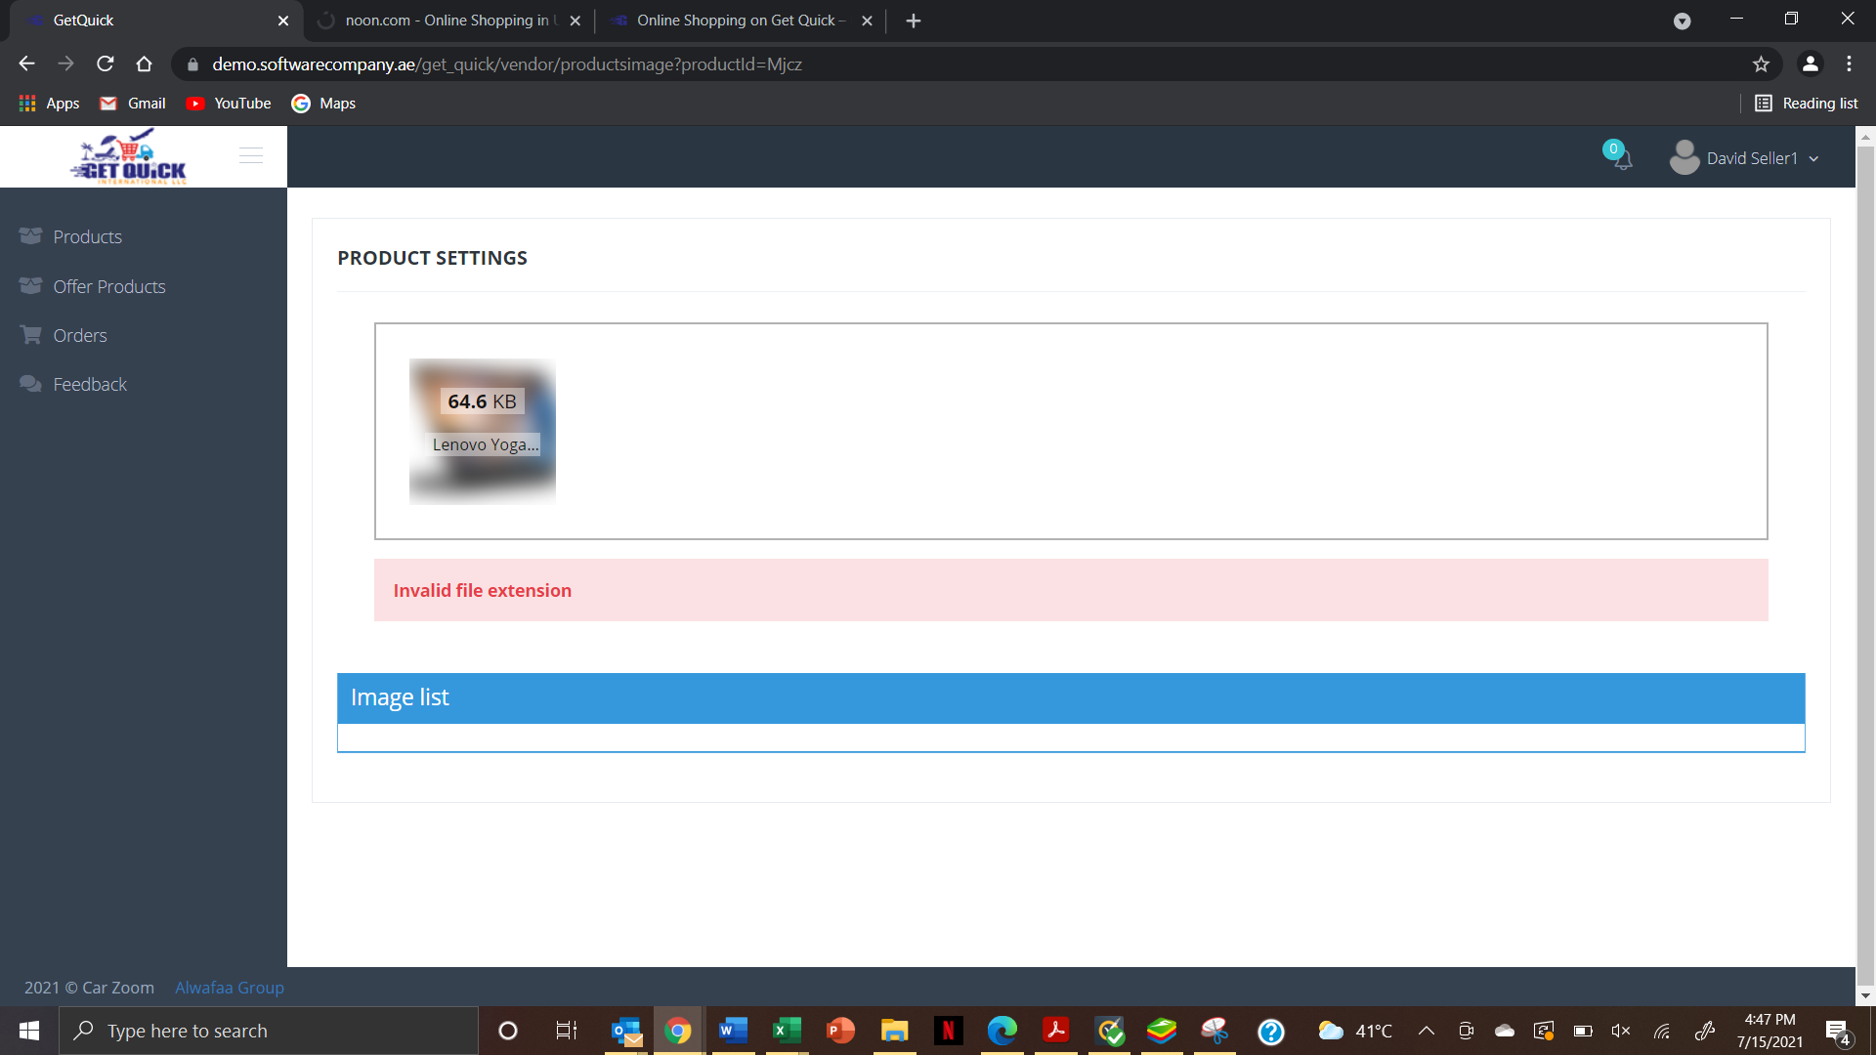
- Dell quantity is 5
- One is product is in cart and later seller applied discount it should reflect in my cart
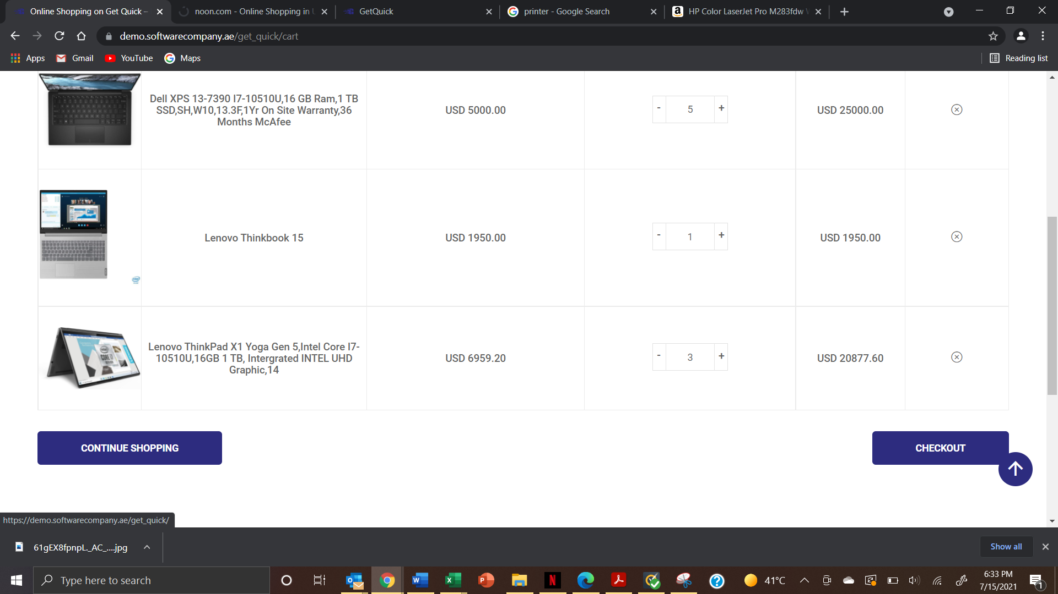
- Added 1more qnty and this is result

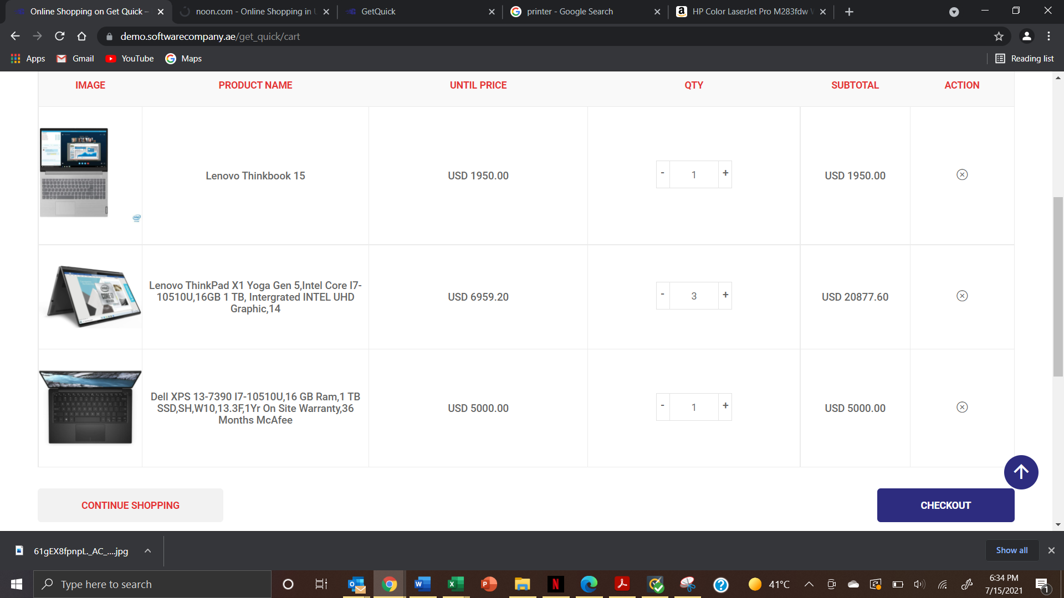
- No discount. I continued shopping

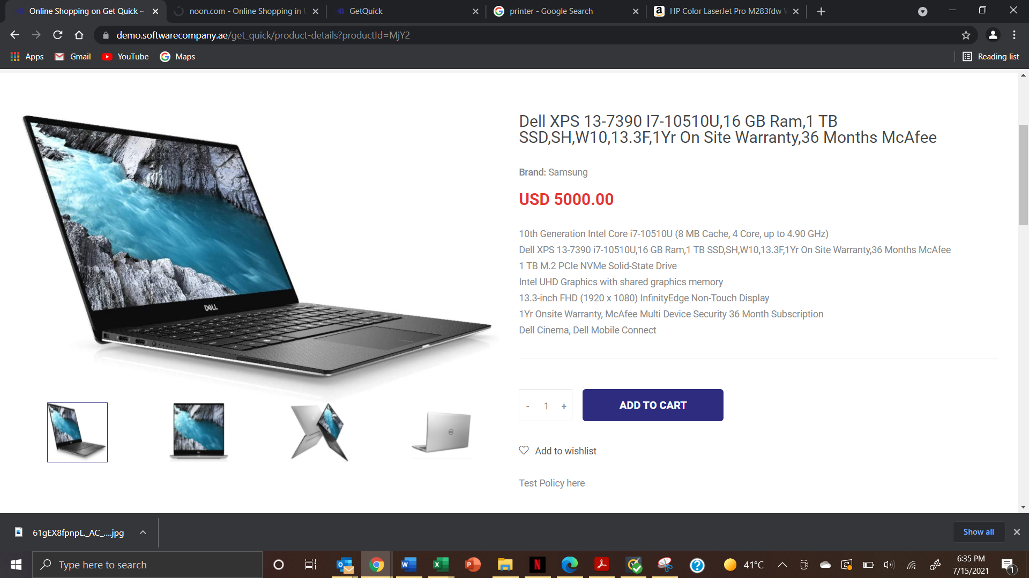
- Adjusted the discount

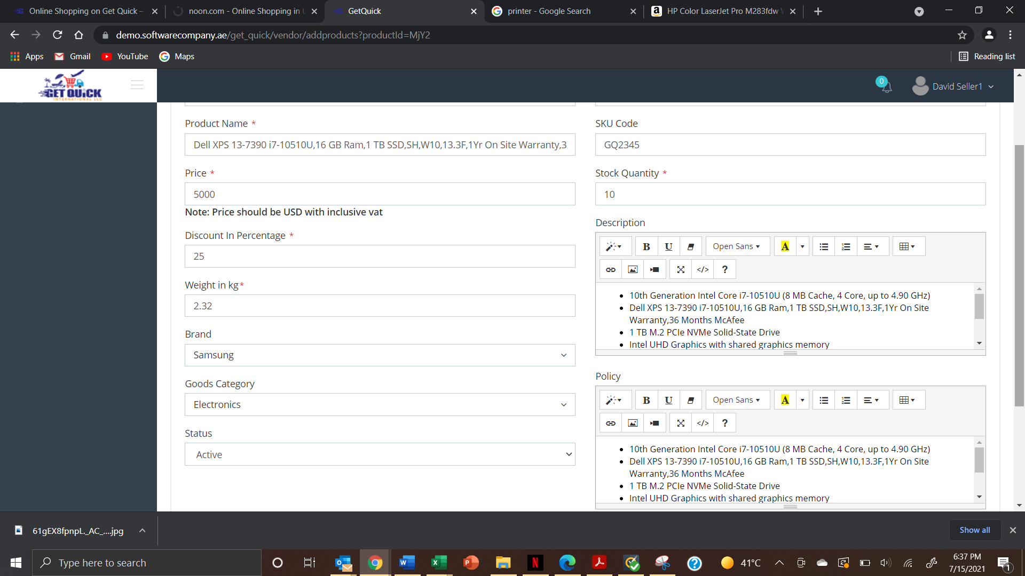

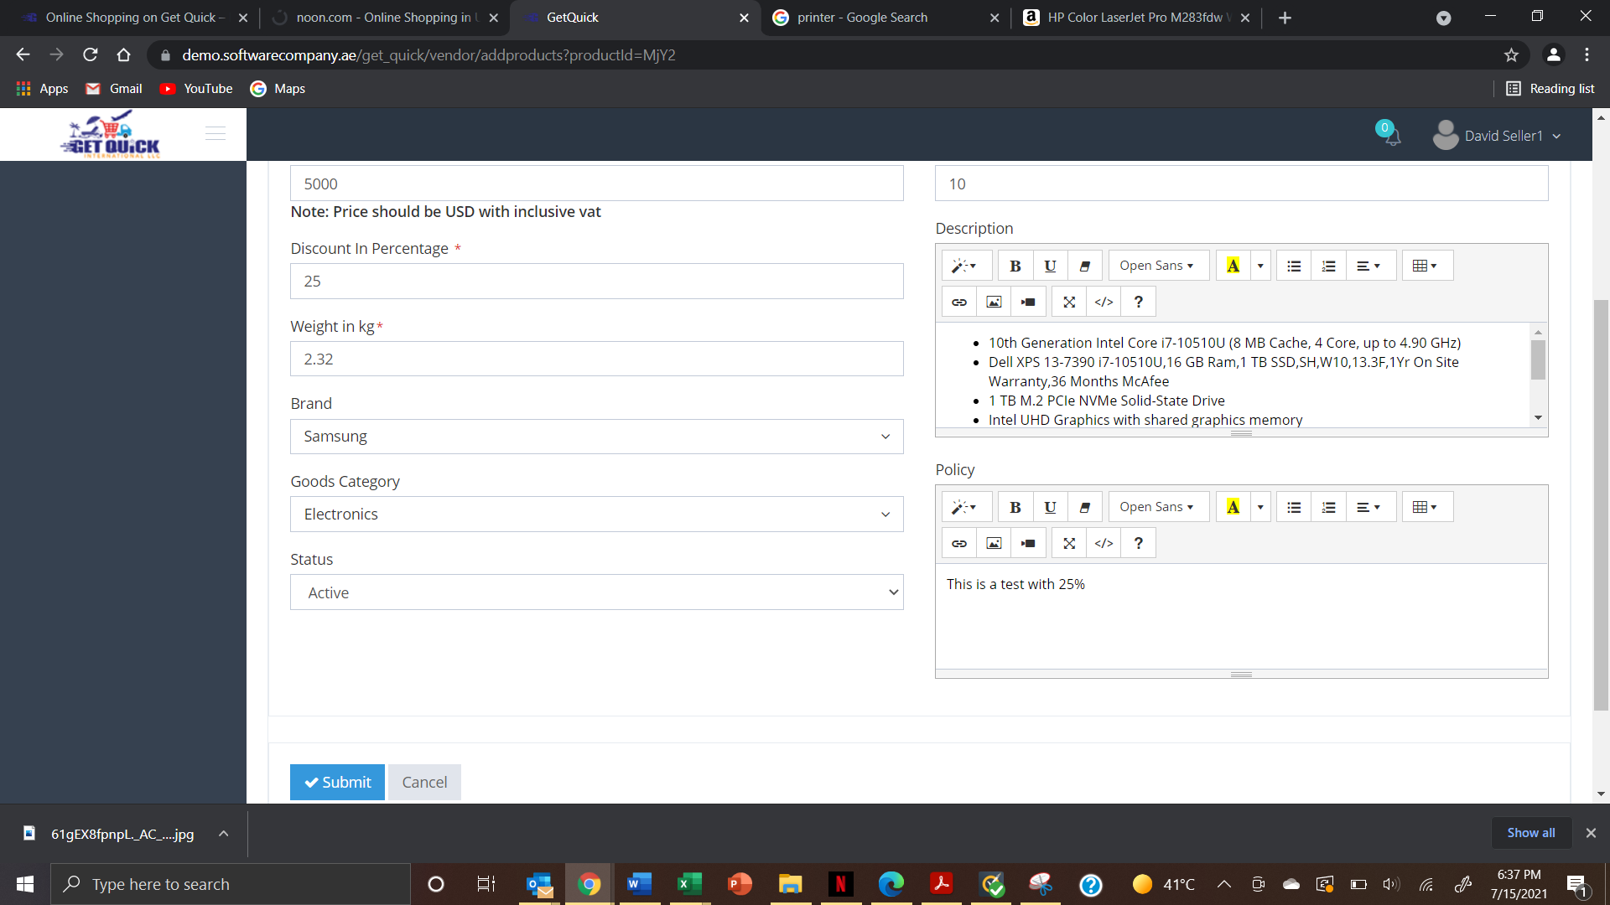
- Add to cart with 25% with another item already in cart (1 item)

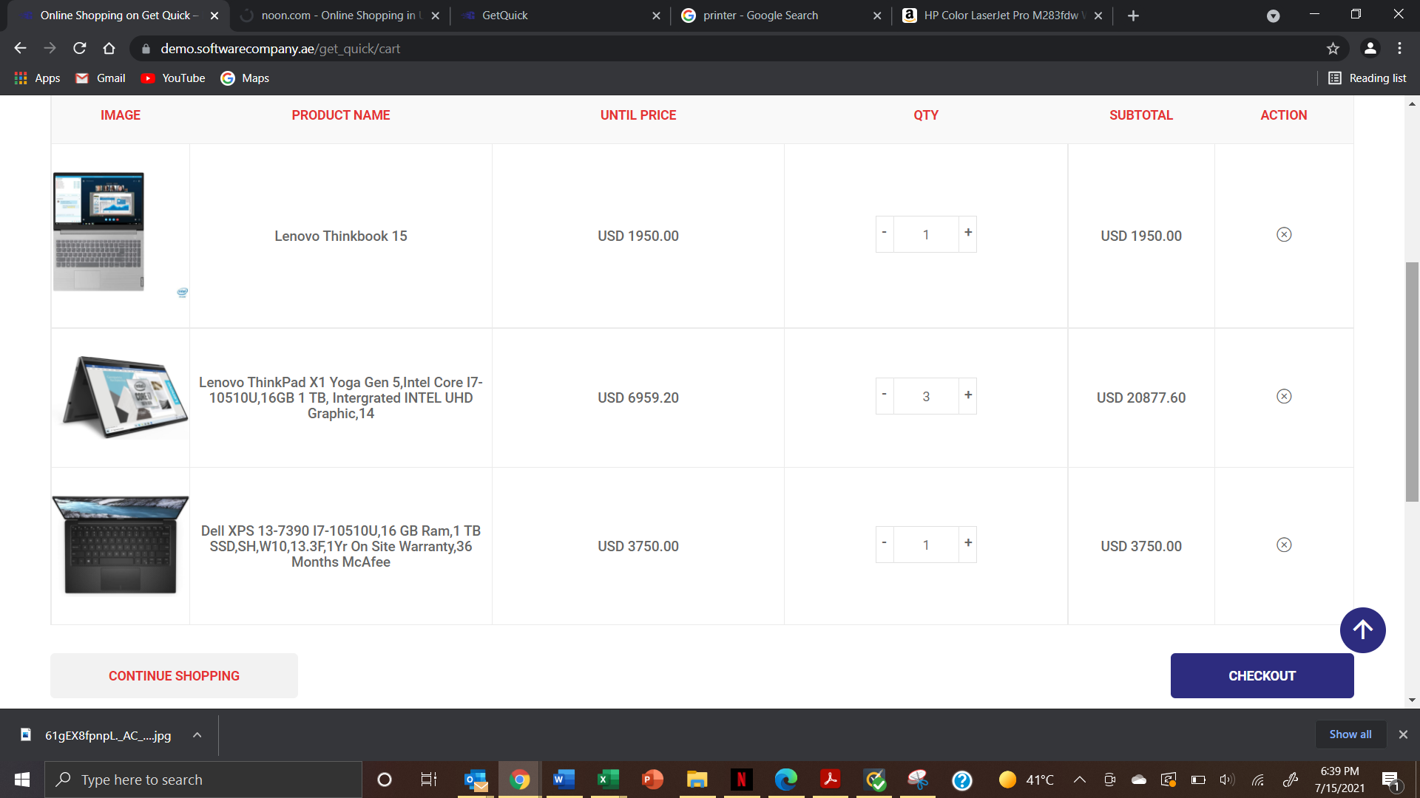
- It removes my previous and adds this new one. Same as before

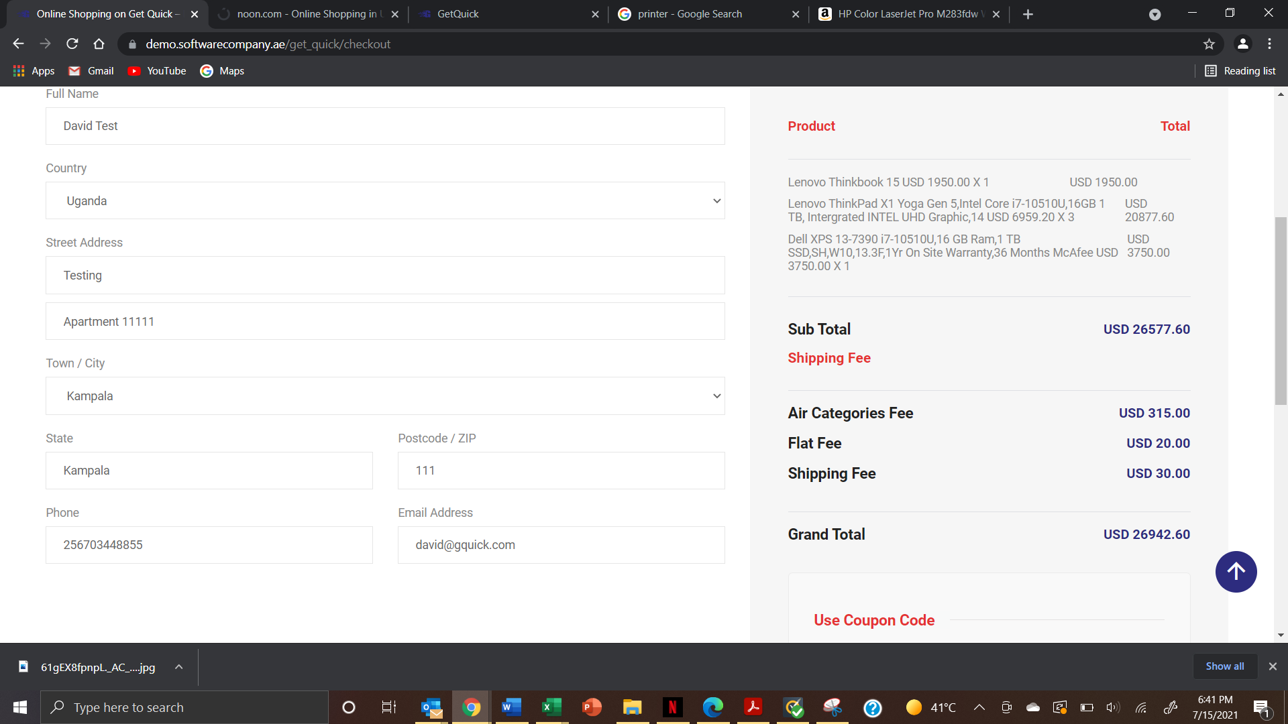
- Where is commission integrated for the vendor – In admin and seller account

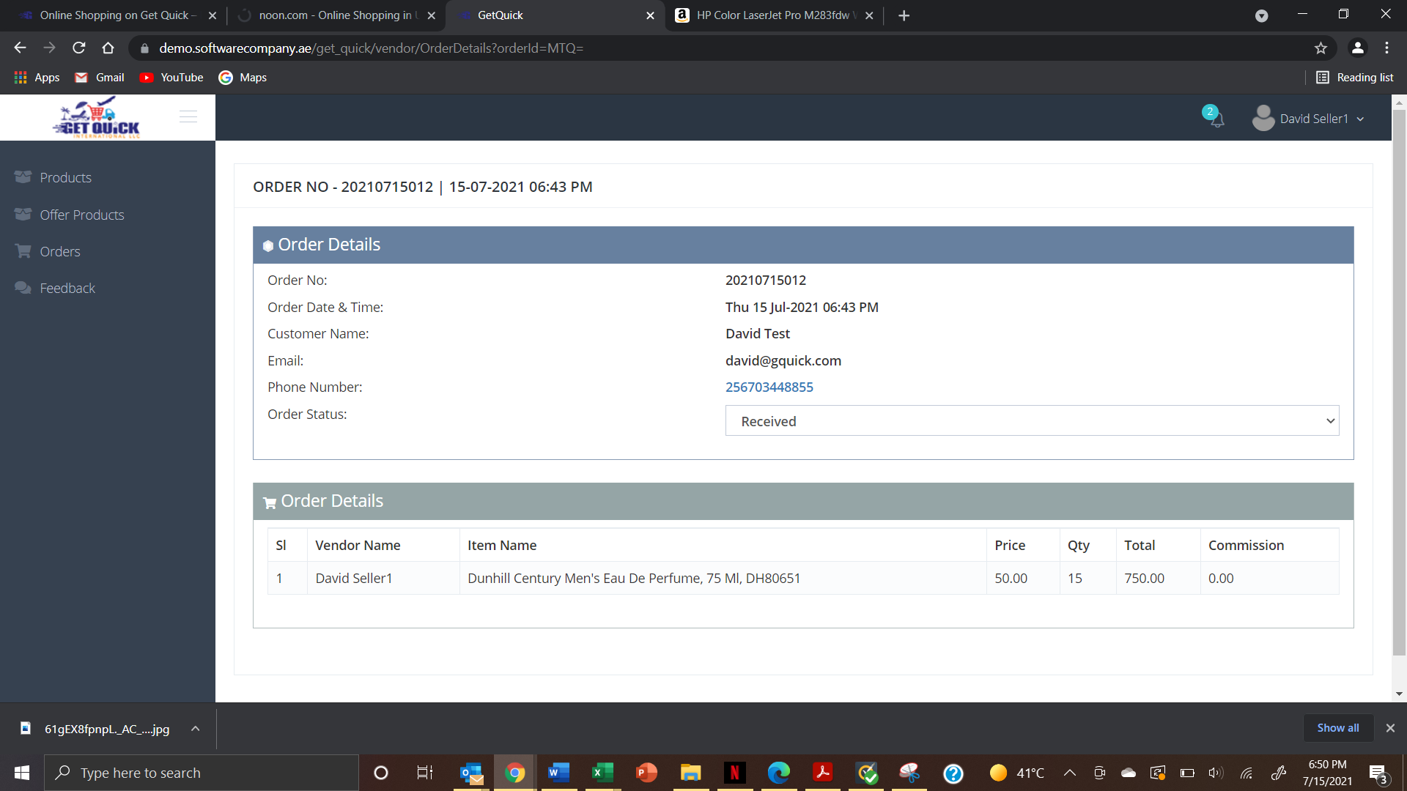
- Can we show status of order on the order page with a quick action on it. – Need to show the current status of the order in list view

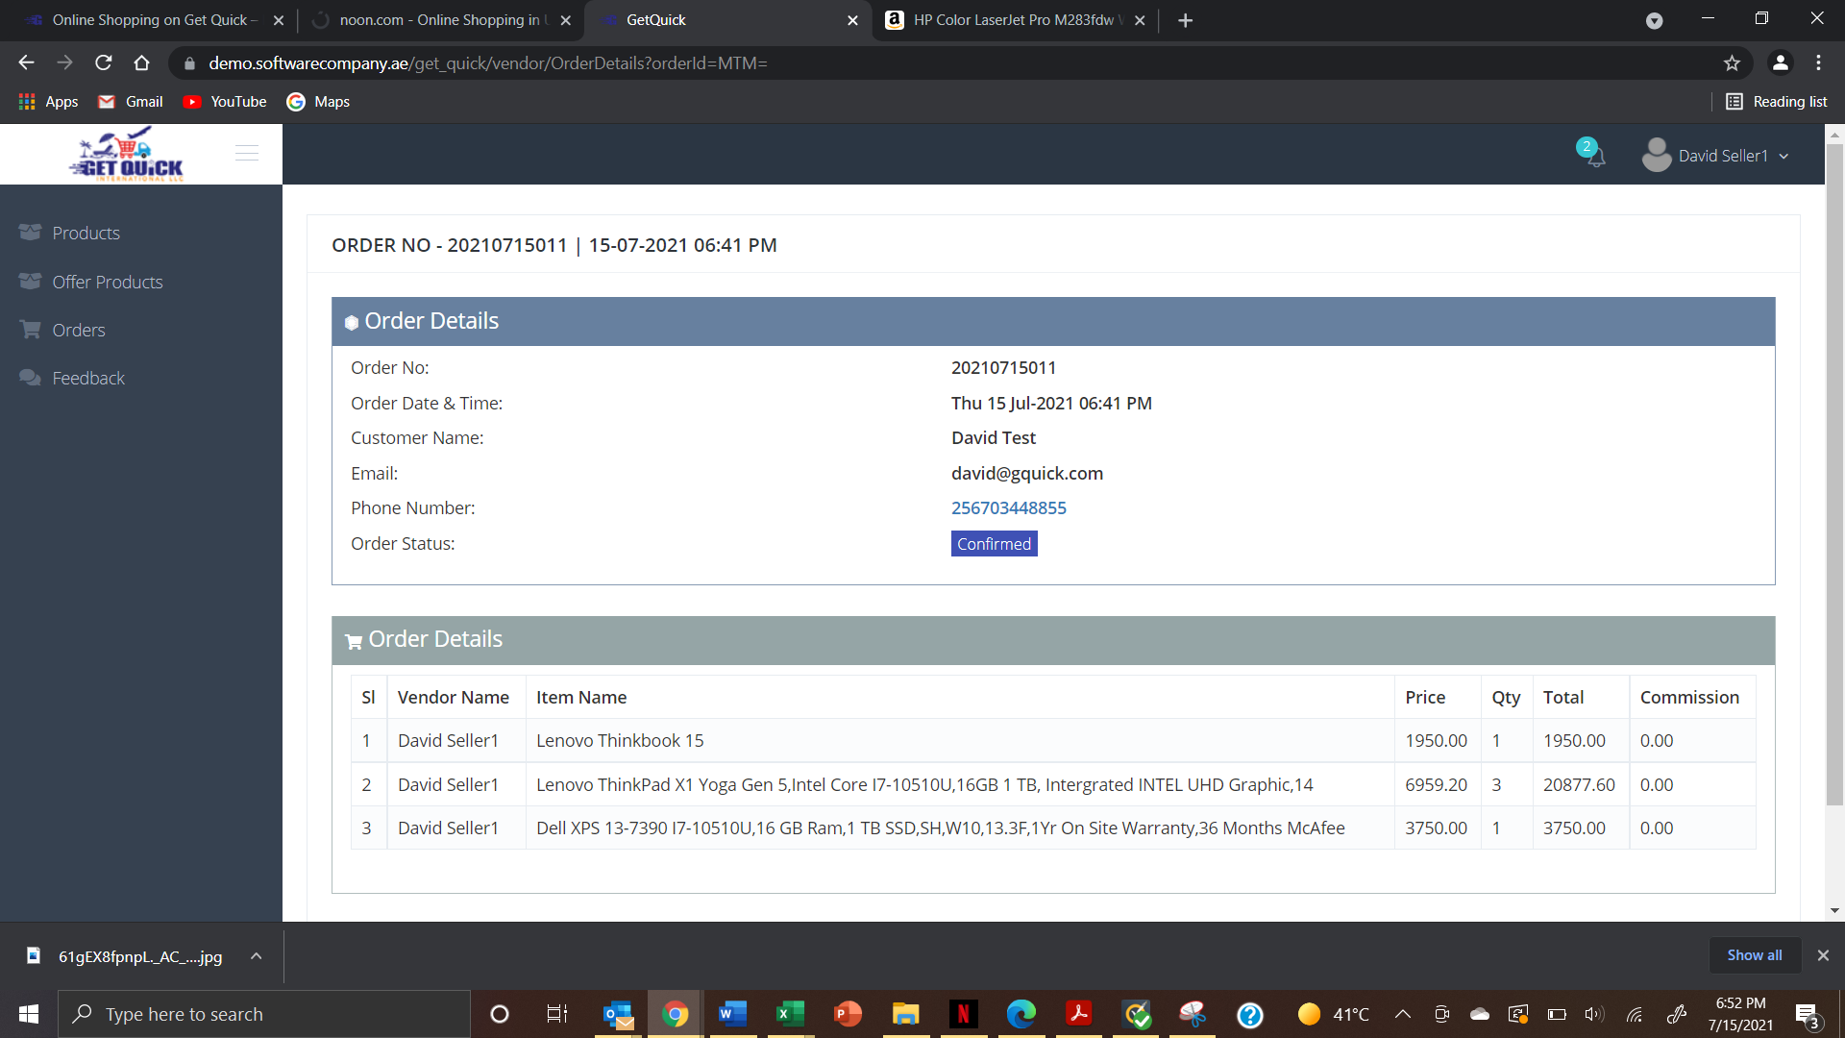
- Does it mean that if a product has an offer on it, then it will appear on the offer page? – Need to check the flow and confirm
- Added review but it doesn’t appear. Why does it immediately choose 5 star review? - Need to check the flow and confirm

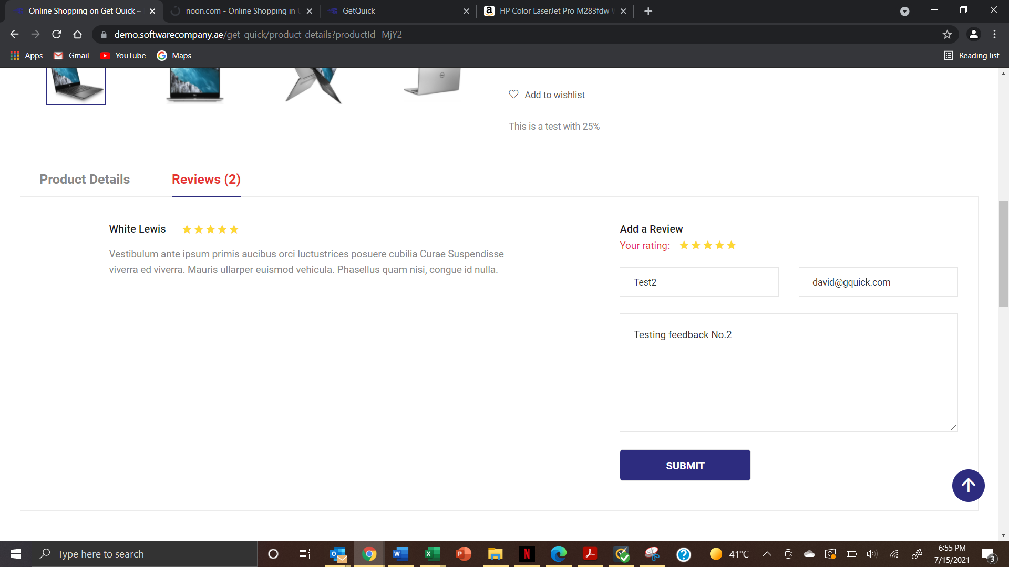
- As soon as I click submit, it takes to another item and not the previous item I was reviewing - Need to check the flow and confirm
- On the order page, mention the currency for the vendor- All values will be in USD
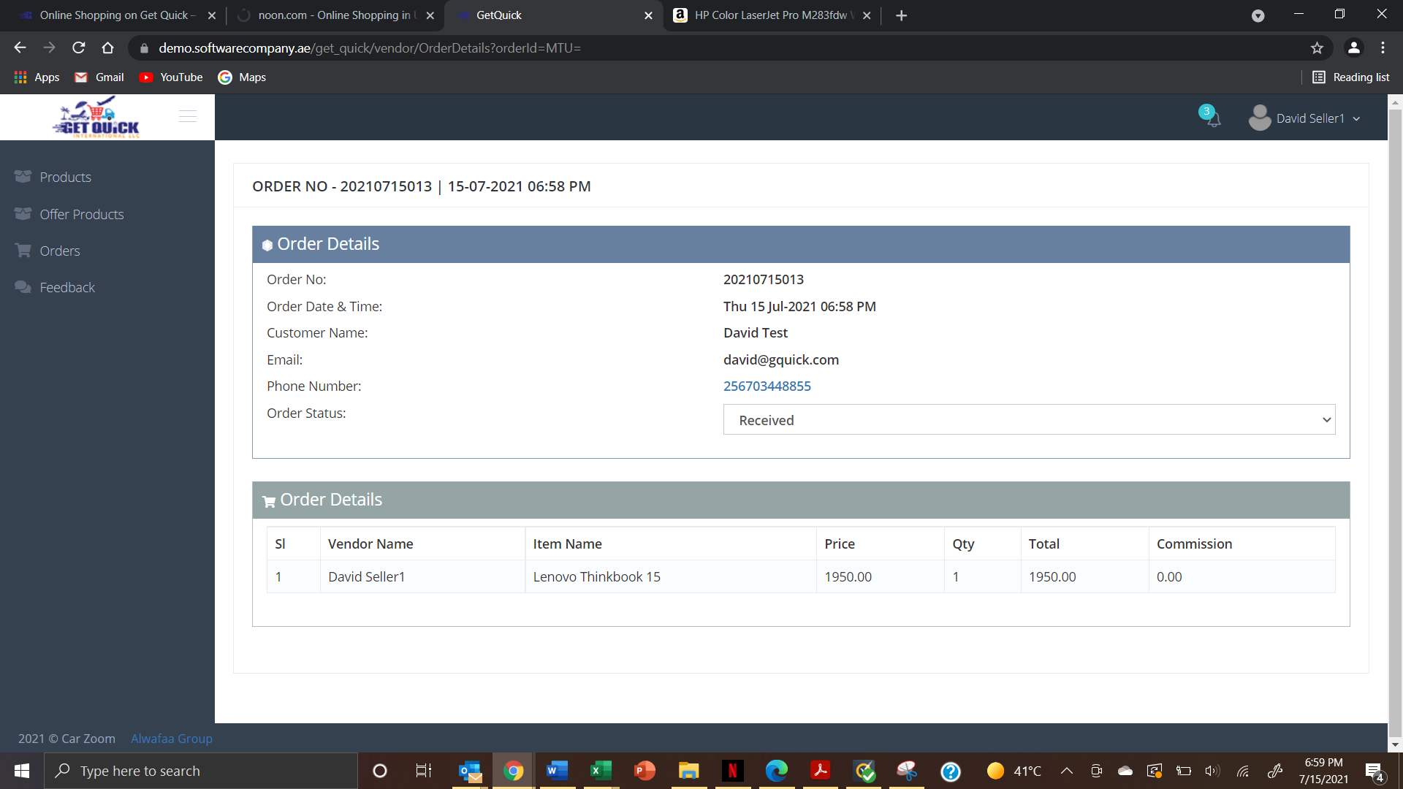
- Same as here (summary page) – All values will be in USD

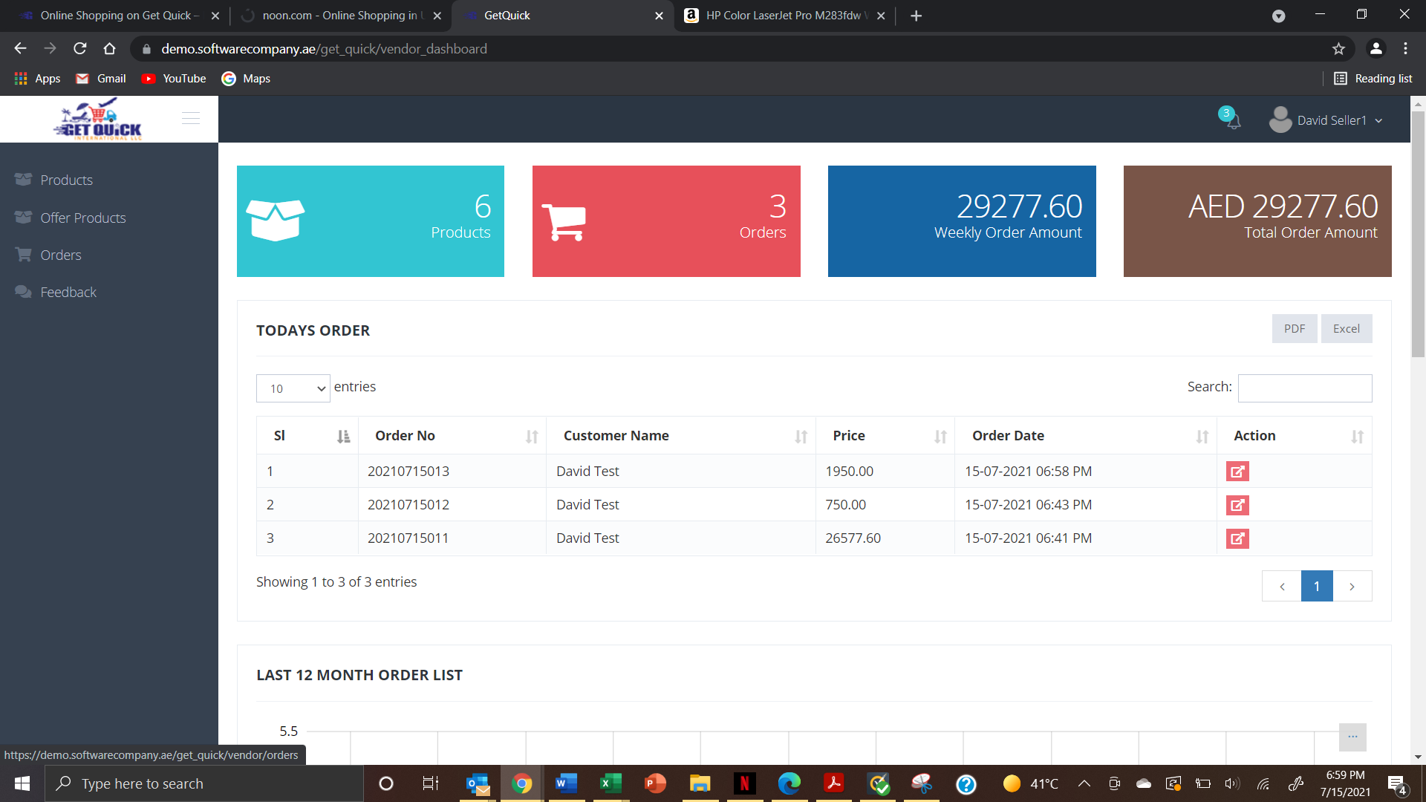
- I don’t understand, income of 5 on the graphical below – Need to recheck the Graph values
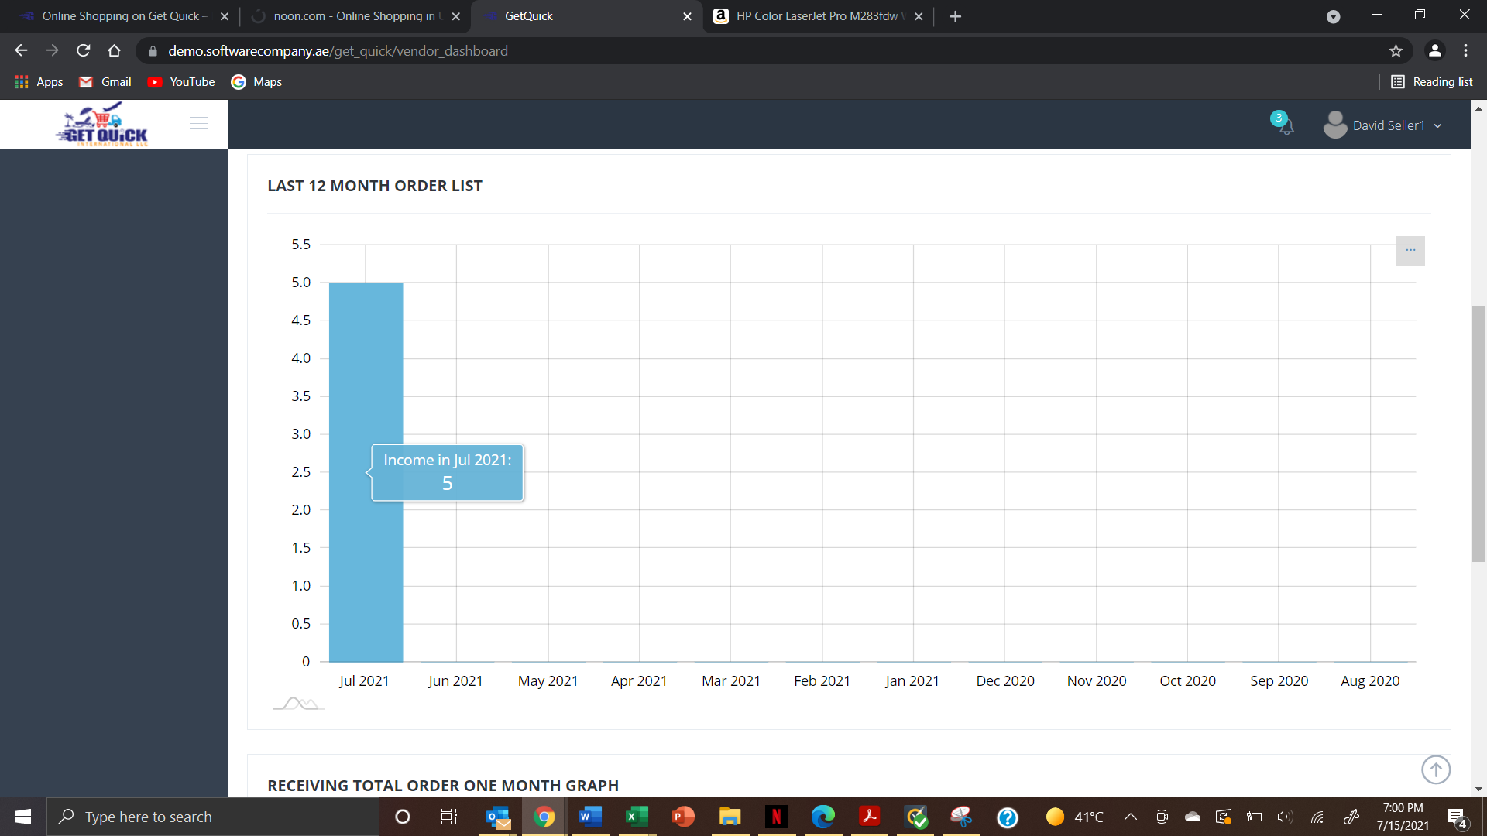

- In Order Table – need to show Delivery Country
- Admin and Vendor – all Amount values will be in USD

New Points

- Add new address option not there in - Addresses page
- Order cancellation notification (mail) not getting.
- Change the email logo (@ bottom)
- Kindly check the banner page redirection - It will done once the client will upload the URls
- Wish list added product (delete or remove) option missing
- FAQ page (change alfabee to getquick)
- Contact us - Google map not working - Will work when the project on live
- Search option not working.
- Service book page (gender alignment issue, date, message not editable)
- Seller verification issue. (Mail received but unable to active the verification)
- The text at the top left corner, please make it Welcome to Get Quick International! And make same font size as Login/Sign In that’s in the right corner
- Under the currency tab, the UGX (or Uganda) country flag is missing
- Cart added product (delete or remove) option missing.
- Password policy need to update
- Updated account details are not reflected in my accounts page
- Email verification not working
- Order page border not proper
- Payment gateway integrated.
- Add seller account management
- Checkout page design

